Team Name: Quality Improvement Support Team (QIST) – Adult & Children’s Acute Services NHS Lothian
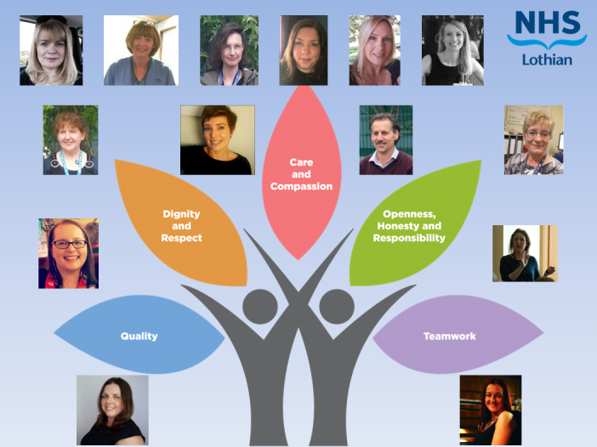
Quality Improvement Begins at Home
Who are we?
The Quality Improvement Support Team (QIST) is a part of the wider Quality Directorate. The role of our team is to enable services, using a Quality Management approach, to plan, improve and assure the quality and safety of care across Adult and Children’s Acute Services. We work with lots of individuals and teams on many different types of projects and subjects.
We are a team of 14 spread across a number of sites (Royal Hospital for Sick Children, Royal Infirmary of Edinburgh, St John’s Hospital and Western General Hospital). The fact that we are so widely spread means that we have to work that much harder at maintaining our relationships and ensuring we have good communication across the team.
Following our initial iMatter report in 2017, we considered ways in which we could improve the experience of being a part of our team.
Our main steps so far:
- Our first step was to give ourselves permission to spend regular, dedicated time focusing on our own team when our work is usually focused around how other teams work
- Support from colleagues in Organisational Development (OD)
- Progressing through our Affina Organisation Development (AOD) Journey
- Identify a facilitator for AOD
- Monthly One to Ones with Line Managers
- Setting a “Question of the Month”
- Participating in a Leadership Compass Exercise
- Arranging a Healthy Working Lives Session for our Team
- Alternating the location of our monthly Team Meeting
- Working on creating and improving an Induction Package for new members of our team
- Celebrate/supporting one another with life events with cards, cake, gifts, etc
Affina OD Journey
With the support of NHS Lothian OD we introduced the concept of the AOD journey (aka Aston) and were enthusiastic about the benefits that it could bring to our team. We agreed a team member of our team facilitate AOD, with support from OD colleagues, this was to ensure we could take ownership and ensure it remained one of our priorities. Identifying a facilitator was key to driving AOD forward and the successes. The facilitator prepares and plans for each session, our roles are clearly defined and the facilitator keeps us all to time to ensure we achieve the desired outcomes each time we meet.
As we are a very analytical team, our journey has not been rushed. So far we have really firmed up our Team Identity and Objectives, which are such an important aspect to get right. As part of defining our Team Identity we set a number of team operating principles, which can be thought of as our team’s ground rules or culture. This is something we have been able to demonstrate measureable improvement on, with most recent questionnaires showing higher average scores and no “disagree” or “strongly disagree” responses.
Our future AOD steps are improving effective team communication, increasing role clarity, improving decision making, increasing constructive debate and improving inter-team working.
Monthly 1-1s with Line Manager
Monthly team meetings and one to ones with our Line Manager have helped us in terms of understanding our direction/focus and expectations. It keeps us up-to-date with any changes in priorities and allows us a proactive awareness of what is coming. It also allows us to highlight achievements and discuss any issues in confidence.
Question of the Month
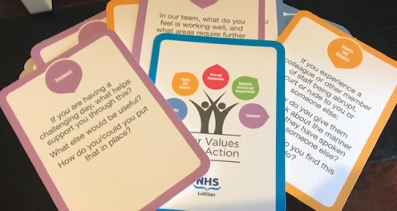Every month a member of the team selects a question from the NHS Lothian: Our Values into Action cards. Responses are collected anonymously via Survey Monkey. Collated results are circulated and later reviewed at the next team meeting, where any actions are agreed.
Leadership Compass Exercise
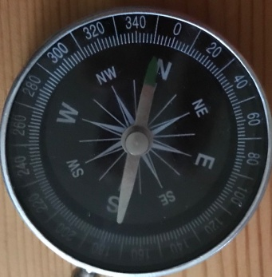
It was really good to see how we work together, complement each other’s styles, etc
We have support from OD colleagues who always have some extra tools that we can use alongside AOD. The leadership compass exercise helped us further understand and appreciate our own and one another’s work preference/direction and communication styles. We considered how others may interpret the way we communicate and work and how it may affect them, as well as thinking about the best ways to communicate with one another and the benefits of having different approaches. We also identified any gaps in our team and actions that we may need to take to address those.
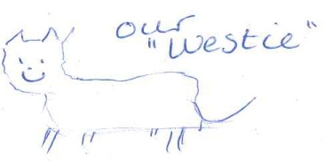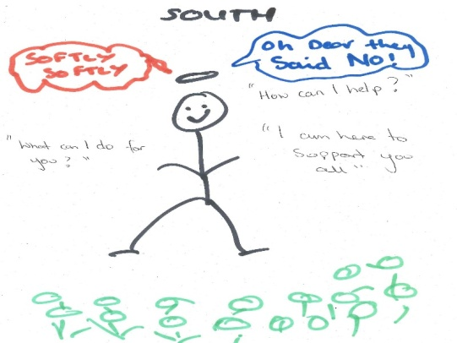
Next Steps: We plan to do a similar exercise as the team has new team members joining.
Healthy Working Lives Session
The team benefited from a “Time to Recharge” session provided by our Healthy Working Lives Co-ordinator. It was helpful to remind ourselves about the importance of breathing, staying hydrated, looking after ourselves, taking a break and practising compassion.
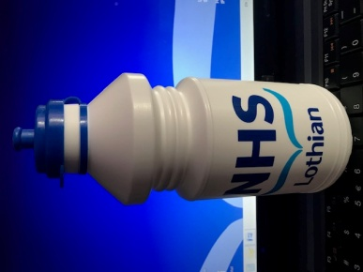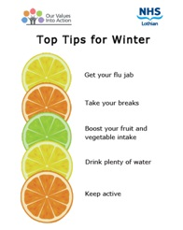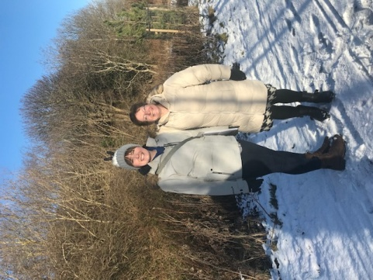
A brisk walk and chat at lunchtime on a wintry day helps to refresh us!

What’s been good?
Have a supportive team and good working relationships.
The team meeting which includes coffee and cake and birthday cards is a positive too! 

Good communication amongst the team.
Autonomy.
Camaradarie.

Knowing you can ask for help when needed.
Each of us offering to help others in the Team.

Our next steps are: To continue with the work we are doing with a focus on effective communication, evaluating and improving our Team Meetings.
Our team has changed since we began this journey with new members bringing a whole range of different skills, knowledge, experience and competencies valued as part of team development.

