NHS Lothian Everyone Matters Story
The COVID Tree – Ward 208, Royal Infirmary of Edinburgh

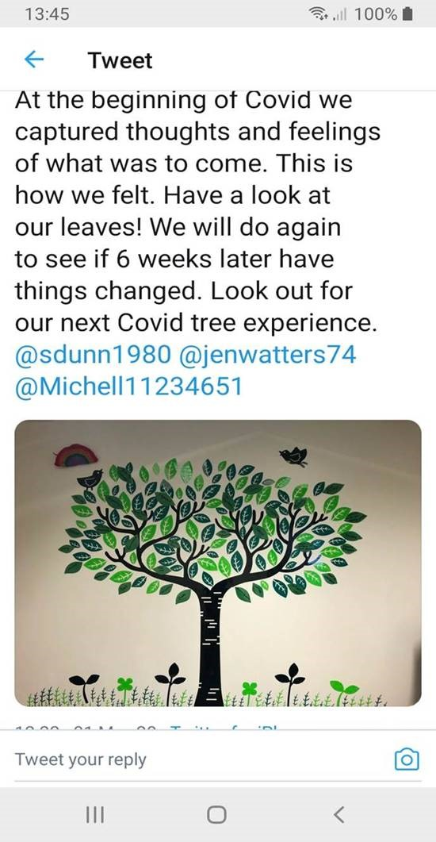
RIE Ward 208 Twitter Feeds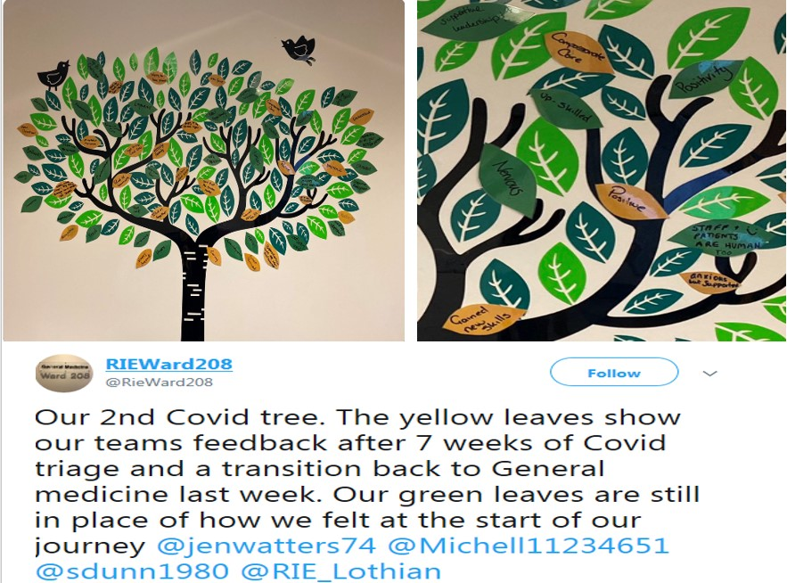

Ward 208 at the Royal Infirmary of Edinburgh added the Covid Tree to their ward following the success of the use of the Scotland wide “What Matters to You” campaign. This campaign worked well within Ward 208 encouraging meaningful conversations between the team and the patients, and their families, regarding their personal experiences on the ward.

Following the success of this campaign, the team looked for a way to take this on to the next level whilst adding a visual aid for all to see within the ward. The Covid Tree was considered an opportunity to reflect upon the feelings and thoughts of both patients and the team at this difficult time and a box of paper leaves and apples was made available next to the tree for patients and team members to add to the branches of the tree. All “leaves” were welcome, whether comments were positive or negative. The “leaves” would highlight feedback, thoughts and feelings and could reflect the mood within the ward, whether a team member had completed a particularly good or difficult shift, how a patient was feeling on that day or how a visitor experienced their time whilst on the ward, when visitors were allowed.

When the leaves and their comments are reviewed this provides the team leader and the team a commentary on the recent mood and morale within the ward for both patients and staff. As Senior Charge Nurse Kenzie Smith advised “it (the Covid Tree) can give staff feedback in real time and shows the “pulse” of staff feelings”.

The “leaves” of the tree provide the basis for future goals plus an opportunity to reflect for the team within Ward 208 and are reviewed approximately every 6 weeks.

In keeping with the season, the leaves are about to fall from the tree and new leaves are expected in the coming weeks.

