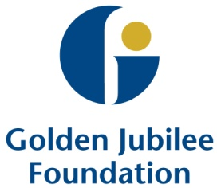
Golden Jubilee Foundation - Pharmacy Team Story
What we do well

‘Work together as an adaptable and accommodating team utilising the skills of all of our team members to deliver a good pharmacy service’
How we developed our Action Plan

We couldn’t all get together at the one time and maintain the pharmacy service to the hospital so we split the team in to two ensuring a good mix in both groups. Both groups met on the same day. Both sessions were facilitated by one of our senior pharmacists and we split the group into groups of 3 or 4 to enable focussed discussions on the following:
- What we did well
- Areas for improvement
- Desired outcome
- Actions
Each small group was then asked to feedback verbally and discussion points were captured on a flip chart. This process was repeated for group 2 and the outputs compared. The content of the flip charts were similar for both groups.
What our areas of improvement are

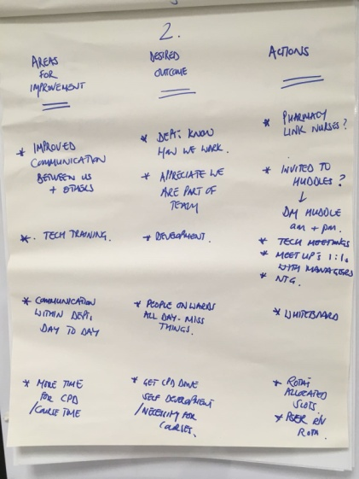
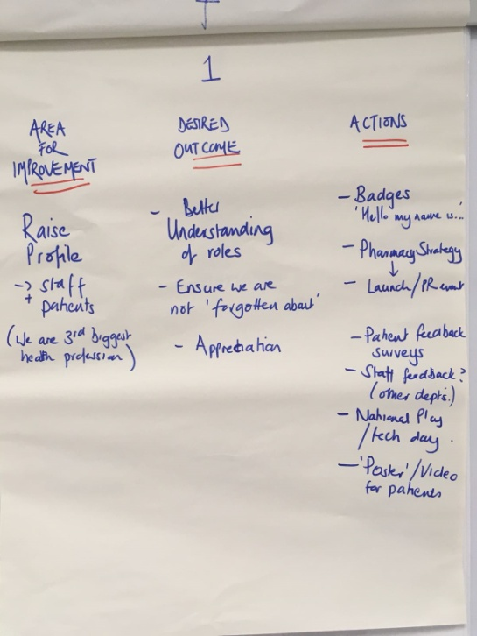

- The profile of pharmacy
- Communication within pharmacy and between pharmacy and the hospital
- Peer review
What we have done so far

In the first few months since we developed our action plan we have begun to make improvements on our three key areas. We have introduced name badges for the whole team which clearly state to patients and colleagues what our name is and that we work in pharmacy. We celebrated the role of Pharmacy Technicians on Pharmacy Technician Day in collaboration with our comms department. This has helped to raise the profile of the role of pharmacy technicians.
We have introduced fortnightly pharmacy peer review meetings. This is a chance over lunch for team members to lead a session and share learning.
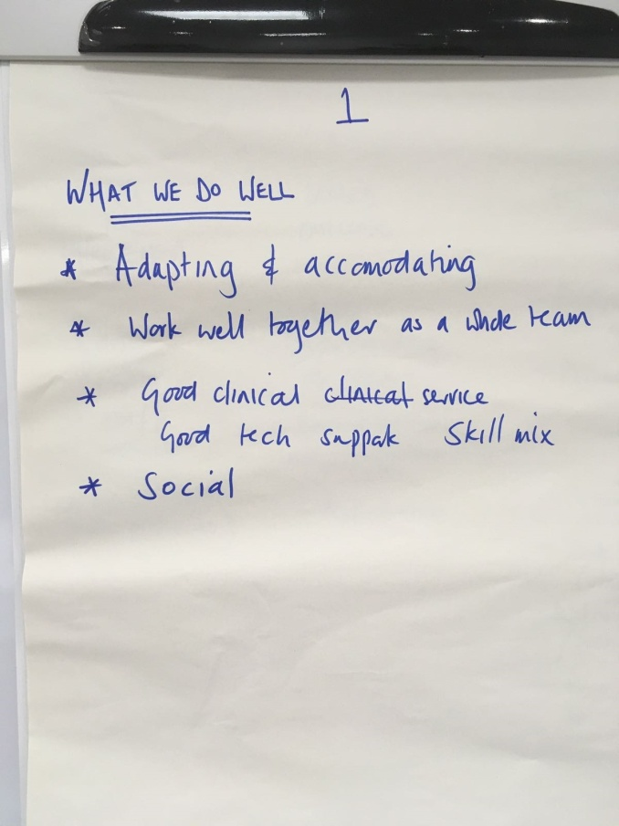

As the year progresses, we will work through our actions for our 3 areas for improvement.

Benefits of developing our action plan

Coming together as a team to discuss our iMatter report provided an excellent chance to recognise what we do well and agree areas for improvement that we can work towards as a team.
