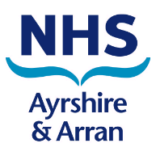
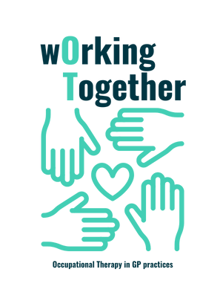
The Working Together OT’s in GP Practices is part of the wider occupational therapy team within NHS Ayrshire and Arran.
The team has eight Occupational Therapists who are based within 17 GP surgeries in Ayrshire. The team work closely among the three localities to ensure consistency of service across the different areas.
The service was established in April 2022 following a successful pilot within 3 GP surgeries where the benefits of having an OT within Primary Care were recognised.
The aim of the service is to allow earlier access to an Occupational Therapist to prevent/delay functional decline, to help maintain independence and improve quality of life. The service aligns with NHS Ayrshire and Arran’s Caring for Ayrshire vision to provide better local access to MDT’s within GP practices to allow the patient to see the right person, at the right place, at the right time and recognises that this is often within local communities.
We offer short term (4-6 sessions) holistic assessments and interventions that are aimed at providing self-management strategies for anyone experiencing physical health difficulties/mental health difficulties, or quite often, both physical and mental health difficulties. For example, the OT would work with someone with anxiety to ensure they can leave their home independently; the OT can support someone to return to or stay in work; educate a person with pain and fatigue to plan, pace and prioritise activities to establish a manageable daily routine.
In the first year;
- The service received 1209 referrals with a 17% increase in referrals in the second half of the year.
- There was an average reduction of 64% in GP appointments following OT intervention.
- 84% of patients did not require onward referral to secondary services.
- 100 % of patients reported they would access OT support again
- 96% of patients reported that they felt OT was easy to access and that they were seen in a reasonable timescale.
- Occupational performance was improved following OT intervention.
Service user and MDT feedback included
“You literally saved my life” (patient)
“The OT saw me as a whole person, the help and guidance I received has improved my quality of life” (patient)
“The impact is huge, helps patients, decreases further visits and decreases prescribing” (GP)
The team were also fortunate enough to be finalists in two categories at the Ayrshire Achieves Awards 2023, placing in the top three out of 126 nominations.
Submitted by: Lynsey Cameron, Advanced Practice Occupational Therapist - Primary Care South

