The State Hospital Story – Staff Health and Wellbeing (as part of overall Staff Governance Standards section)

Promoting positive staff health and wellbeing

Introduction

The health and wellbeing of our staff is always of paramount importance to us. This has never been more crucial than it is during the current pandemic.

In keeping with, and in addition to, national guidance set out in DL (2020)8 - Staff Wellbeing and Support: Employers’ Duty Of Care During COVID-19 Pandemic (The Scottish Government, 2020), we adopted a wide variety of measures to help promote positive staff health (both physical and mental) and wellbeing. These included:
- Frequent and multiple communications about the ‘ProMIS’ National Wellbeing Hub, to help create an awareness about this excellent resource and to encourage our staff to visit and make use of it
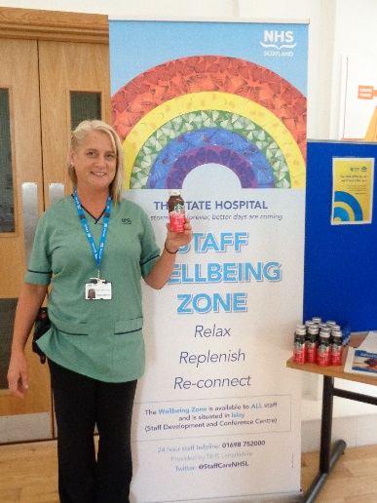
- Developing and introducing our own local ‘Staff Wellbeing Zone’ (replete with an array of equipment and resources to promote health and wellbeing, e.g. massage chairs, exercise equipment, access to mindfulness classes and to information about other ‘self-soothing’ strategies that staff might use to help manage times of potential stress and/or distress)
- Equipping all ward staff areas with massage chairs and information about accessing other resources to help promote staff health and wellbeing
- Providing a daily ‘Covid-19 Bulletin’ to help facilitate regular communication and keep our staff informed about the ever-changing situation d
- During the pandemic, and about our local and national responses to it
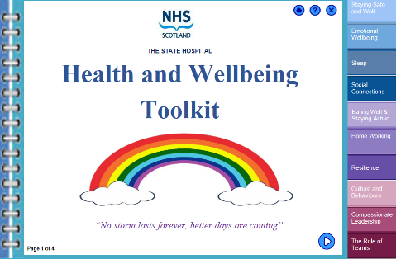
- At a practical level, providing soup and a roll to all ward-based nursing staff to ensure that they had access to food and fluids during each shift
- Providing increased opportunities for staff to gain additional line manager/supervisor support should they wish it
- Creating an awareness about, and providing increased access to, psychological first aid for staff
- Giving information to all staff about how to access more formal psychological support should this be required

Gauging the impact

To check whether these measures were in fact having a beneficial effect on staff health and wellbeing, we then devised a service evaluation strategy. The aims of this were to:
- Gain an awareness and understanding of the current levels of health and wellbeing across all staff groups
- Gather staff members’ views on the usefulness and effectiveness of the various measures adopted to promote their positive health and wellbeing during the COVID-19 outbreak, including identifying any areas where there may be gaps in our current service response, to enable us to proactively address these
- develop our overall understanding of staff’s views about ‘what works’ best to promote their positive health and wellbeing, to help inform our longer-term planning in this area
To gather this information two staff survey questionnaires were devised to be delivered over two separate time points. Results from the first of these surveys are outlined below.

Results from initial survey

Not only did 227/683 (33%) of our staff complete this first survey, but the spread of responses gained from across all disciplines also suggested that we manage to achieve a good representative sample of our entire staffing population.

From the provisional analysis of these results, we found that the levels of staff health and wellbeing reported at this time point were much in keeping with pre-Covid-19 levels in our staff group. We also know from previous research undertaken in our hospital, that how safe staff feel is linked to their wellbeing. It was therefore good to note that, again, from this first survey, we found that the majority of participants (66%) reported feeling safe at work. The majority of staff (ranging from 71% - 87%) also reported that they found all the current national and local measures adopted to promote their health and wellbeing during the pandemic to be useful and effective, and many asked for initiatives like our local Staff Wellbeing Zone to continue to be available going forward.

Massage Equipment

Staff Feedback

Staff Ideas

Space to Take a Break

Treats
Helping our local communities

Next steps

The second survey questionnaire, which constitutes the final part of our service evaluation will be completed over Winter 2020, when some of the longer-term effects of the pandemic may be beginning to be felt. Results from this second survey will also be reported once this is completed. This second set of results will then be contrasted with the results from the first survey and used to help inform our continued approach to promoting positive staff and wellbeing in the longer-term.

