Employee Voices
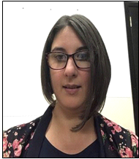

Barbara- Anne Cleaver – Speech and Language Therapist
“We approached deployment with humility, acknowledging from the outset that we didn’t have all the answers. Instead, we tried always to “listen to understand”, and act in a way that staff felt they had truly been heard. Over the course of the 12 weeks, the underlying causes changed and evolved – initially our anxiety was around managing a team we had never met, and the fear of exposure to the virus – particularly exposing our families who had created a ‘safe’ bubble at home. It became a balance – to be human and travel the journey alongside our colleagues, without our anxieties affecting the team.
As time moved on, and we became more comfortable in our roles in the teams, our anxiety shifted to what we were missing in our own department and how it would be to find our place back in the team.
“In saying that, the experience has had a positive impact. I have gained in confidence in my seconded role, and I have built relationships with AHPs that I would not have met otherwise.”

