Supporting Staff And Patients To Cycle Throughout COVID

Aileen Schofield, Health Promotion Officer
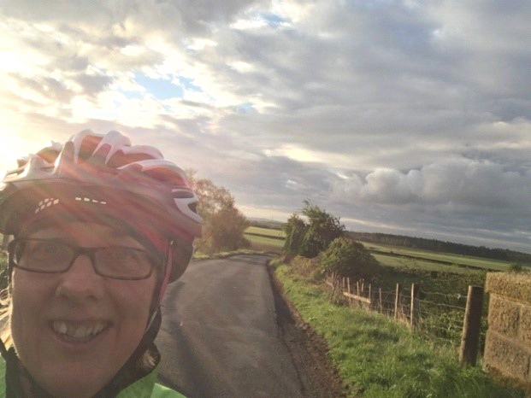

Lockdown started in late March 2020 and this meant that those staff who came to work in a car share, couldn’t continue to do so and also bus and train routes were substantially reduced to re-enforce the message of lockdown and the need to be socially distant. Up until then, I had been working closely with our local Active Travel Hubs (collectively part of Forth Environment Link) to encourage, enable and support staff, patients and visitors to cycle and walk more.
Just as lockdown started, we had a telephone conversation where we talked of our work stopping at that time and this discussion naturally progressed to where their CEO wanted to show support for NHSFV staff at this frightening and uncertain time resulting in Forth Environment Link making their very kind and generous offer to our staff to borrow one of their eBikes to help them get to work during lockdown.
This offer was promoted to staff via the intranet front page and also I developed a “Physical Activity for All During COVID e-bulletin” which brought together various free opportunities for NHSFV staff to still be physically active throughout lockdown. From the beginning of the lockdown, The Government and Scottish Government actively recognised the importance of physical activity to our mental health and wellbeing and also to our physical health and as such they encouraged us all to go out once a day for physical activity.
The response from NHSFV staff to this offer was tremendous and way more than we could have hoped for. All 60 e-bikes were quickly snapped up and a waiting list started. At its peak, 92 staff were on that waiting list. As word reached staff that the waiting list was so long, they stopped contacting FEL about the eBike loans. I really feel that had we been able to access bikes for everyone who wanted one, we would have seen staff in the hundreds using them. From here, I started the process of applying for funding with support from FEL (and this involved late nights working on the bids – 11.30pm and beyond which I didn’t mind as I wanted to try and gain the funding for more bikes for our staff) and Mark Craske and me have been successful in the 2 bids we have submitted worth a total of £55,000.
One is for 20 e-bikes for NHSFV staff and one is for 26 bike vouchers for lower paid staff and 33 D locks for the first 33 staff members who applied for a bike as part of NHSFVs Cycle scheme since April 1st 2020. To get word back that those bids had been successful was simply joyous as they would whole heartedly benefit our staff. The 20 e-bikes are on order using local bikes shops, which is keeping the money in the local economy, the D locks are with the 33 staff and we are in the process of identifying the staff who will be offered the 26 bike vouchers, again all going well staff will use local bike providers thereby keeping this money in the local economy. (not directly from me as such but we generate ideas between us all - but a natural progression has been the development of a wrap around service for each of the eBikes and our staff members.
Each eBike has its own film showing how to work the e-bike for staff to watch, the bikes are serviced on a regular basis, they are picked up and dropped off using social distance protocols and hygiene measures, if the staff member has a puncture or issue, FEL’s bike mechanic will go to them, try and repair the bike and if this is not possible, the member of staff will be dropped off at work, the bike taken for repair and be ready for the staff member as they finish their shift. Advice and support is always available to our staff at the end of the phone from FEL).
In May, staff who had one of the borrowed eBikes filled in a short FEL survey and to read the feedback from them in terms of what the bikes had meant to them was quite emotional at times. What shone through was the benefit to their mental health as well as physical health from using the bikes. To date, 81 NHSFV staff have borrowed one of the e-bikes and the waiting list is in the low 50s now. We anticipate that the above mentioned funding will reduce this waiting list further once the bikes arrive / vouchers are issued and used.
We now have another brilliant opportunity of free TACTRAN cycling training available to our staff, family, friends and patients, their family and friends and this is currently being promoted to staff. We have supported similar training in the past from the Cycling Officer at Falkirk Council and the staff who attended that session really valued it. I plan to take further develop our good partnership working with TACTRAN for the benefit of our staff, patients and family members.
When I moved over to this role, simply through an initial, early conversation with the Bowel Cancer Clinical Nurse Specialist at FVRH and then a different conversation with FEL’s CEO, this sparked ideas which have culminated (after a huge amount of work and joint energy from everyone involved) in a multidisciplinary and multiagency bowel cancer patient and eBikes pilot going ahead.
I mentioned above that we generate ideas from each other and based on feedback from staff, I ask if it was possible to increase the amount of the Cycle scheme loan for staff from £1,000 to £2000. This has happened. The next discussion that will take place strategically is for the consideration of the loan timescale to be extended for certain grades of staff to 15 months and review?
I just look for opportunities and run with them. I have great partnerships that are a joy to work with and between us all we are making things happen that will benefit our staff and patients. I know the NHS structures and have great partnership relationships externally and internally, I can approach the right people to start a conversation and share ideas, listen, and make it work. This bit sounds awfully big headed but I’ve been told that without me, none of this great work that we are all working together on, would be happening. That is really humbling.
One final but very important point for me is that the above success is all down to my new, fantastically supportive, enabling, respectful, and ambitious Lead Health Promotion Officer Anita Paterson. Without Anita, none of the above would have happened.

