Promoting a positive culture within NHS Ayrshire and Arran
NHS Ayrshire and Arran has embarked on a pioneering, ambitious and visionary programme of reform in order to deliver, excellent, sustainable services to our citizens.
As leaders, every one of us plays a vital role in taking our work forward and keeping our focus on what really matters. Every one of us counts and our leaders have a critical role in helping to communicate our vision and engage with local teams to enable them to get involved in contributing their ideas, suggestions and encourage a culture in which feel able to speak up, be open and honest and provide constructive challenge to how we do things.
Building psychological safety in our teams is a core leadership responsibility and we have developed a range of interventions and resources to provide an understanding of what this is, together with some materials to help our leaders develop local action plans to promote and encourage an effective culture for all of our staff.

Between January and February 2020, 18 culture workshops were locally facilitated across all Directorates and HSCPs open to all staff to engage in discussions about the culture and values within NHSAA and gain feedback on what is working well and areas for improvement. The output from the workshops was reported to the Corporate Management Team and will inform the Board’s overall culture framework and improvement activity as we strive to be an exemplar employer.
(See Appendix 2 and 3)
23 sessions on Psychological Safety were delivered during November and December 2020 attended by over 450 clinical and non-clinical leaders from supervisory to director level.
The session promoted the concept of psychological safety and explored what this means for staff. Leaders developed local actions plans and personal pledges to improve engagement, encourage openness and diversity of views in support of the reform agenda.
In addition, a Leaders Guide was developed and issued to all leaders providing additional reading and tips on Psychological Safety. (See Appendix 1)

Appendix 1

Psychological Safety Handbook for Leaders – see separate PDF document.

Appendix 2

Managers/Leaders Guide for Engaging with Staff

1. Culture Workshops

The People Plan for 2019/20 identifies the requirement for Directorates/HSCPs to deliver a series of culture workshops as noted below:

General Corporate Services minimum of 1 workshop by February 2020

HSCPs minimum of 2 workshops by February 2020

Acute and Corporate Support Services minimum of 3 workshops by February 2020

The purpose of these workshops is to engage with staff across local service areas and seek feedback on culture, values, attitudes and behaviours and explore what is required to support the conditions for a positive and healthy culture.

This guide has been developed for senior leaders to assist them in the design and delivery of local culture workshops. This includes a draft outline for the one hour workshop together with draft slides which are optional for use in the workshop. The guide can also be used as a general resource at any point when engaging with staff to discuss the culture within NHS Ayrshire and Arran.

These culture workshops have been designed to build on the Daring to Succeed, Leading Reform workshops delivered in November/December 2019 for all leaders/supervisors across NHS Ayrshire and Arran to help them understand the conditions necessary to create a psychologically safe culture to underpin the organisation’s strategic objectives and values.
a) Questions to explore during the culture workshops
The main aim of these workshops is to gain views and feedback from staff on the current culture within NHS Ayrshire and Arran and the suggested questions below would be useful to refer to during the discussion to help ensure feedback is consistently assessed in all Directorates/HSCPs.
Culture
- What kind of culture do you think exists within NHS Ayrshire & Arran?

- What kind of culture do you think exists within local teams/services?
- Can you give any examples which you feel demonstrate the culture (positive or negative) in either the organisation or our team/service?
Refer to Ayrshire and Arran’s values: Caring, Safe and Respectful
- What kind of behaviours have you seen demonstrated within NHS Ayrshire & Arran?
- What kind of behaviours have you seen demonstrated within local teams/services?
- Can you give any examples which you feel demonstrate the behaviours (positive or negative) in the organisation or local teams/services?

General discussion
- Do you feel able to speak up, challenge and offer ideas/suggestions?
- How does it feel to work in this local service/what do we do well?
- If it needs to be different – what would that look like? What could we take away to create space for reflection/building relational kindness?
- Do you feel supported in keeping well – if not, what more can we do?
- How can we improve diversity of ideas and opinions
- What could we improve at local and organisational level for staff to feel valued, listened to and able to contribute to the overall vision, goals and objectives for Ayrshire & Arran?
b) Draft Outline for 1 hour culture workshop
5 mins Welcome and introduction
Clarify the purpose and approach of the workshop (refer to slide 3) and ask staff to introduce themselves by name and role/service area. This helps everyone to have an appreciation of who is in the room.
20 mins Refer to slides 4 and 5 to set out our aspiration for a culture in which there is a commitment to the work, respect for policies and guidelines, where people understand their roles, have opportunity to learn, space for their voice to be heard, employees have a sense of belonging. Our intent is for staff feel safe to speak up/challenge, offer views and suggestions to help support the delivery of our organisational vision, purpose and goals.
Explain that there is an organisational commitment to this and that the information gathered from the workshops will be collated and reported to the Corporate Management Team when it meets on 17 March 2020. Key themes and priority actions based on the feedback will be captured in the People Plan for 2020/21.
15 mins Use flip charts or post its and invite staff to describe the culture within the local directorate/HSCP by considering the questions below (slide 6) : (The flip charts can either be placed on tables or posted on the walls)
What kind of culture do you think exists within local teams/services?

Can you give any examples which you feel demonstrate the culture (positive or negative) in either the organisation or local teams/services?

How does it feel to work in this local service? What do we do well?

If it needs to be different – what would that look like? What could we take away to create space for reflection/building relational kindness?

15 mins Refer to Ayrshire and Arran’s values – Caring Safe and Respectful (slide 7)
Use flip charts and post its to capture views on the questions below (slide 8)
What kind of behaviours have you seen demonstrated within NHS Ayrshire & Arran?

What kind of behaviour have you seen demonstrated within local teams/services?

Can you give any examples which you feel demonstrate the behaviours (positive or negative) in either the organisation or local teams/services?

Do you feel able to speak up, challenge and offer ideas/suggestions?

How can we improve diversity of ideas and opinions?

What could we do to improve at local and organisational level for staff to feel valued, listened to and able to contribute to the overall vision, goals and objectives for Ayrshire and Arran?

Refer to slide 9 and explain we are endeavouring to build a Wellness “movement” across the organisation so that wellness is intrinsic within our culture

As a final question ask staff “Do you feel supported in keeping well – if not, what more can we do?”
5 mins Summarise what you have heard from staff today. Advise that the output from workshops across all Directorates/HSCPs will be collated and shared with the CMT on 17 March 2020. The key themes from the overall feedback will be used to identify actions which will be captured in the People Plan for 2020/21
Advise of any future engagement and ask staff to get involved
Thank staff for attending, invite feedback on whether they have found the workshop useful and then close the workshop
The attached slides have been included with the option to be used as prompts during the corporate workshop.
c) Additional Background Information
General Engagement with Staff

NHS Ayrshire & Arran have used engagement sessions to inform various pieces of work over the last few years, for example, when we were developing our values and behaviours, focus groups informed the final decision to adopt our three values of Caring, Safe and Respectful.

General reasons for engaging with staff
- discover how different groups think and feel about a topic and why they hold certain opinions
- inform decision-making, strategic planning and resource allocation
- investigate the use, effectiveness and usefulness of particular means of communication
- verify or clarify the results from surveys
- suggest potential solutions to problems identified
- to add a human dimension to impersonal data
- to deepen understanding and explain statistical data.

Advantages of engaging with staff
- it is useful to obtain detailed information about personal and group feelings, perceptions and opinions
- it can provide a broader range of information
- it offers the opportunity to seek clarification
- staff feel more comfortable discussing topics in small groups rather than in individual one to ones or large group settings

We need to hear views and suggestions from all staff across Ayrshire and Arran to help us deliver an even better service to our patients and be an exemplar employer to our staff.
When engaging with staff, whether on a one to one or collective basis consider the following:
Setting the stage
Framing the engagement
Have I clarified the purpose/reason for the engagement? To what extent is our service complex and interdependent? How well do I assess shared understanding of our work priorities and the desired culture/values and behaviours?
- Have I spoken of failures in the right way? Do I point out that small failures are the currency of subsequent improvement? Do I emphasize that it is not possible to get something new “right the first time”?
Emphasizing Purpose
- Have I clearly articulated the vision, purpose and goal of Ayrshire and Arran?
- Have I clearly articulated why our service matters, why it makes a difference and for whom?
- Even if seems obvious given the type of work our organisation, how often do I talk about the four pillars, Caring for Ayrshire and achieving financial balance by December 2020 to help make them meaningful for local teams?
Inviting participation
Situational Humility
- Have I made sure that people know that I don’t think I have all the answers?
- Have I emphasised that we can always learn more? Have I been clear that the situation we’re in requires everyone to be humble and curious about what’s going to happen next?
Proactive Inquiry
- How often do I ask good open questions rather than closed or rhetorical ones? How often do I ask questions or seek views from others, rather than just expressing my perspective?
- Do I demonstrate an appropriate mix of questions that go broad and deep?
Systems and structures
- Have I created structures to systematically elicit ideas and concerns?
- Are these structures well designed to ensure a safe environment for open dialogue?
Responding productively
Express Appreciation
- Have I listened thoughtfully, signalling that what I am hearing matters?
- Do I acknowledge or thank the speaker for bringing the idea or question to me? Do I listen thoughtfully?
Destigmatize Failure
- Have I done what I can to destigmatize failure? What more can I do to celebrate intelligent failures that have helped with organisational learning?
- When someone comes to me with bad news, how do I make sure it’s a positive experience? Do I help them to understand the reasons for not adopting an idea or suggestion?
- Do I offer help or support to guide the next steps?
Building psychological safety
Psychological safety is in place when staff feel safe to speak up, offer ideas and challenge. Trust, respect and effective communication is fundamental for this to be in place.
From a leadership perspective, it means focusing on the following:
- Encouraging and supporting openness of debate, contribution and perspective. At times your discussions may be challenging due to the diversity of opinions and perspectives– yet this challenge provides the ability to be innovative. Conflict and tension is to be welcomed when it is respectful and in service of our work. People can understandably feel very emotional and impassioned about their perspectives, and as a leader it can be a delicate balance to support expression of this whilst containing the potential for it to get personal.
Conflict is not about our worth as individuals or perceived rights and wrongs of our personal views about things. Conflict is the point at which different world views bump into each other. Our focus as leaders needs to be, how can this conversation serve our work and what we want to deliver together? Our culture at the moment can be conflict-avoidance due to our tendency to take things personally, and so our ability to keep returning to the work will help us to build resilience and skills in these discussions.
- Maintaining transparent, continuous and responsiveness communication. In order to feel safe it is important that communication is open, and that it is done in a considered way. Many of us work in a reactive or crisis oriented environment and so our culture is to fire off emails and information ‘as it happens’ often unwittingly, rather than take the time to speak to people when this would deliver a far better outcome. This can be confusing and even feel undermining for people when we are seeking to embed a proactive culture of planning and joint working, and in the early days, can unwittingly undermine confidence in the work.
Everything we do as leaders makes a difference. Part of our role with communication is to keep returning to what it is we want to achieve, and to choose the most appropriate way of doing it. The volume of communication we all experience in the 21st century is so intense that many of us feel we do not have the time to invest in face-to-face communication, or to lift the phone. If we believe this we don’t see the reality, which is the amount of time we all spend in dealing with the consequences of not communicating directly, and the loss of trust and responsiveness that follows.
- Staying focused on reality. By definition, a reactive/crisis culture is full of stories and behaviours around drama, catastrophe, shroud-waving, blame and defensiveness. Our leadership role is very much around holding an overview of what is happening such that everyone’s perceptions and lived experience are taken into account, yet do not supersede the facts and wider context of the situation. Furthermore it is important to bring people back to a place where options and possibilities for interventions can be identified and assessed. This re-ignites ownership of the situation and power/responsibility to act.
As this culture is built over time in our teams, they will recognise their own pattern of crisis and be in a position – there and then – to choose different responses. If fear/panic/dogmatism/adversarial thinking sets in, a good place to start is usually with helping people to identify the facts of the situation and the evidence they are basing these on. This calms the situation and invites clearer thinking.
- Building our resilience. Reform does not go in straight lines. There can be sudden, swift and surprising shifts in the work, there can be incremental shifts, and there can be long periods where nothing seems to be happening – and all of this at once. None of this is right or wrong, it is simply what is happening – and our job as leaders is to work with this and stay focused on our vision purpose and goal.
Part of our responsibility and accountability is to resource ourselves to do this, and to build our resilience. This means putting the conditions in place that we need as leaders to respond healthily and effectively to what our work requires of us in our roles, and to do whatever we need to do look after our personal energy and wellbeing. In doing this we empower ourselves to keep perspective as things shift and change, and are therefore more able to stay connected to our vision, be flexible in our thinking, and make the right decisions at the right time.
It is important to remember that our own resilience as leaders is part of our organisational resilience, which is our capacity to adapt to what happens and find creative solutions to any challenges we face.
- Providing assurance regarding diversity.
The key issue for all of us will be evidence of delivery. Without delivery we literally are ‘all talk’. This is an instant energy drain, and the longer it goes on, the more we all get lost in activity that keeps us busy but doesn’t focus on what we need to be focusing on.

In our work to lead reform we need to demonstrate that it is aligned with our vision and ambition for our citizens, our goal of delivering financial balance by 2020, and is addressing any challenges that we have identified. Part of our work as leaders is to help our teams clarify what success looks like for their area of activity, and to translate this into metrics and questions that you will consistently pay attention to thereafter to determine the extent of improvement.

Part of our accountability as leaders it to organise this information so that we can provide assurance wherever and however it is required. The more we hold ourselves to account in how we work and put the right structures in place from the beginning to ask the ‘so what’ question, the more we are on the front foot and the less onerous this becomes.

The only measure of success, in the end, is whether what we are doing serves our vision and the citizens of Ayrshire and Arran. This is why we’re all here, what brings us together and what we have in common. No matter what pressures and demands come to us from our context, we are in the driving seat of our future.

Relational kindness
This article by Charlie Jones and Martin Seager “Humanising The “Machinery” of Care” has resonated with health and social care professionals as we acknowledge the growing body of evidence that shows that positive relationships and kindness are at the heart of our wellbeing.
Resurgence • Article - Humanising the 'Machinery' of Care
Kindness is one of the values which sits at the centre of the National Performance Framework, and our aim in introducing kindness to these engagement workshops is that you get the opportunity to reflect on your working environment and relationships and consider some of the barriers that may stand in the way of relational kindness on a day to day basis.

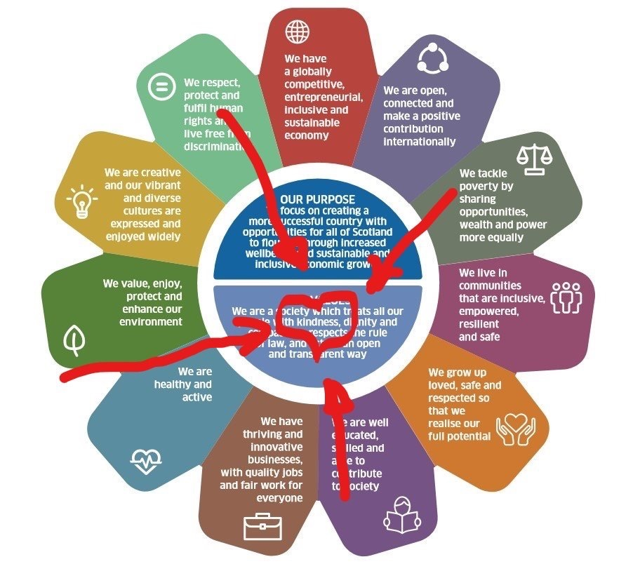

When we talk about kindness we are not referring to random acts of kindness – this is about relational kindness and engaging with patients and each other in a way that involves empathy, warmth and genuineness.
Our system is so cluttered and busy and everything happens at pace, it is not surprising that relational kindness can be forgotten – a cutting remark about a patient or college is made, a poorly worded email sent….
This article makes the link to a “psychologically safe” health-care environment where everyone has a sense of involvement: an environment where conversations routinely happen and there is the opportunity to say what you think without fear

NHS AYRSHIRE AND ARRAN
Appendix 3
Culture Workshops

SUMMARY OF KEY THEMES AND ACTIONS

- CULTURE

- Summary of how existing culture was described by staff

- Positive examples of culture within NHSAA

- Negative examples of culture within NHSAA

- Values

- Positive examples of corporate behaviours

- Positive examples of local behaviours within Directorate/HSCP

- Negative examples of corporate behaviours

- Negative examples of local behaviours within Directorate/HSCP

- General Feedback

- Do staff feel able to speak up/challenge/offer ideas?

- Health and Wellbeing

What more can we do?

- Summary of how it feels to work in NHSAA

4a. Suggested improvements within Directorate/HSCP

4b. Suggested organisational wide improvements to inform People Plan 2020/21

