We have all heard Albert Einstein’s famous quote, “If you do what you’ve always done, you will get what you’ve always got”. Why is it, then, that we often find ourselves doing what we’ve always done even when we know it’s no longer working?

Daring To Do Things Differently: Our Power To Act

No matter how much we enjoy or appreciate particular ways of working, when our work shows us that we are no longer delivering what is needed, we must enact our power to do things differently.

This is where the word ‘daring’ is so important. **When we ‘dare’, we are letting go of our idea of being able to predict and control the future, and the comfort of what we know and are familiar with. Instead, we are trusting what our work is showing us about what we need to do, and trusting each other to connect, work together and find new and better solutions.**

Four Pillars and Personal Development Review

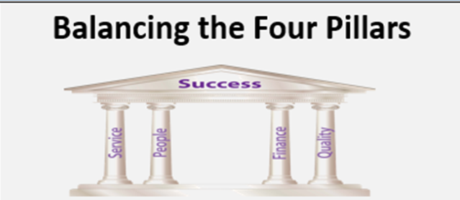During 2020, the Childrens Health Team in South Ayrshire HSCP embarked on a new approach to structure their work and focus thinking on care delivery within teams.

Based on the concepts outlined in the Four Pillars approach of **Service, People, Finance and Quality**, Personal Development Reviews (PDRs) for Clinical Team Leaders were structured to enable objectives to be set which could be cascaded to staff within teams.

The aim was to provide a framework for staff to support their thinking about the valuable contribution they were able to make in each of these areas. Clinical Team Leaders were then asked in turn to discuss with their staff as part of the review process what they felt they could personally contribute within their role under the headings.

Key aspects of service delivery were outlined within PDRs under the **Service Pillar** to ensure team leaders were clear with organisational and service specific requirements for their areas. This included performance in meeting targets in line with the Health Visiting Universal Pathway, Health assessments for Looked after Children, and the national preschool immunisation programme. Specific objectives were also agreed with staff to enhance service delivery where gaps were identified in line with the Health and Social Care Partnership and Children’s Services Plans using the Model for improvement.

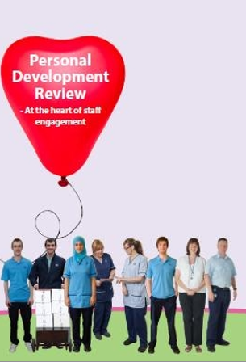The importance of **People** management and investment in our staff and operational processes were also prioritised as part of PDRs. PDR is at the heart of improving staff engagement and providing two way feedback between reviewers and reviewees. Within the **People** Pillar focus was made to support team members to work towards implementation of the School Nursing Pathway including training and development of staff to fulfil the newly refocused role. A focus to ensure safe systems of working were in place such as actions identified through the Safety Action Notification process were also prioritised. The requirement for effective communication within teams which was an improvement identified through previous imatters action plans also made sure there priority was given by team leaders on ensuring regular team meetings were scheduled and individual clinical supervision and child protection supervision sessions for staff were made available to support staff within their roles.

By focusing on the **Finance pillar**, conversations were able to be held in a productive way on how non-essential expenditure could be reduced. This led to conversations around travel, telephone costs and equipment expenditure. There was also a focus on how income could be maximised for families supported by the teams in a bid to empower families, improve health and also reduce reliance on public services in the future. One example of this was work undertaken in conjunction with the NHS Ayrshire and Arran Public Health Lead for Poverty, the South Ayrshire Information and Home Energy Scotland which led to a financial increase of £260,000 being made for families by the Health Visiting teams within the first financial reporting quarter. There was also a focus on PDRs on other financial savings which could be made by families such as increasing the uptake of Health Start vitamins, and access to Scottish Government initiatives such as the Best Start grant.

**Quality** of service provision and support to families is at the heart of all that we do within the Children’s Health Team. Within this pillar a focus on our service Quality Assurance plan identified the requirement for teams to undertake monthly audit and systematic review of patient records to enable service improvement, as well as focus on key clinical outcomes such as improving breast feeding uptake and immunisation rates in specific areas such as the preschool booster and MMR. Objectives were also set with Clinical Team leaders to ensure learning could be shared with all team members through a standardised approaches including use of Organisational Learning summaries. A focus on gaining the views and feedback from parents and carers was also highlighted and objectives set to ensure direct engagement with children and families in this area.

**Summary**

Although this is ‘work in progress’, feedback from Clinical Team Leaders has been very positive. The Four Pillars Framework approach has helped the management team to focus their thinking and structure of the PDR process with staff. The change in the way the team think and work will contribute to delivering improvement, strengthen team working and communication. See examples of Clinical Team Leader objectives will help cascade objective setting within the wider team.

Based on **Daring to Succeed** (2019) Four Pillars, noted below are Clinical Team Leader Objectives produced for 2020/2021;

1. **Service (key aspects of service delivery)**

* Ensure all children and young people receive a health assessment in line with Cel 16 recommendations.
* Ensure the continued implementation of the Universal Health Visiting Pathway for all children pre-birth to school entry.
* Work in partnerships with colleagues within health & social care to provide multi agency training in line with GIRFEC and Child Protection learning need requirements
* Support the delivery of the preschool childhood immunisation programme
* Lead on individual service development areas using Improvement methodology.

1. **People (operational management)**

* C:\Documents and Settings\ad5154\Local Settings\Temporary Internet Files\Content.IE5\CTC74NGR\MC900071375[1].wmfSupport team members to work towards implementation of the School Nursing Pathway including training and development of staff to fulfil the school nurse role.
* Ensure all team members comply with safe systems of working which include use of the Lone worker system and actions as identified through the Safety Action Notification processes.
* Ensure effective communication with all team members through monthly team meetings and individual supervision sessions with all Band 6 staff and above.
* Ensure all Band 6 staff and above are supported to receive Child Protection supervision in line with NHS Safeguarding procedures
* Undertake PDR appraisal for all team members in line with NHS Governance requirements.
* Implement Request for assistance processes to ensure equity of access for support to families from Health Visiting Support workers.
* Ensure the training needs of all staff are identified, and all staff maintain 100% compliance with MAST.

1. **Finance**

* Review and reduce expenditure in relation to travel (and equipment) where opportunities arise
* Maximise income for families through the implementation of the Financial inclusion pathway within teams

1. **Quality (quality assurance plan)**

* Undertake monthly audit and systematic review of patient records to enable service improvement as outlined within the SAHSCP Children’s Health Quality Assurance Plan 2019/20 (SAHSCP QA plan) and SA Children’s Services Plans.
* Ensure learning is shared with all team members through a standardised approaches including use of Organisational Learning summaries.
* Gain the views of service users through direct engagement with families as outlined within the SAHSP QA plan.

***Jayne Miller***

***Senior Manager Children’s Health***

***15th September 2020***

