NHSGGC Mental Health Check In

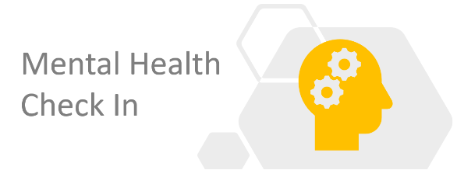

NHS Greater Glasgow and Clyde and our health and social care system has experienced unprecedented activity to help our patients and service users manage through Covid-19. We are immensely proud of our workforce and the way everyone has contributed to support our services. The mental health and wellbeing of all staff is very important to us and we appreciate that you may have lived experience over the past few months that could affect your personal health and wellbeing.
A range of approaches has been introduced to help staff cope with day to day pressures and prevent short-term feelings of distress from becoming something more serious, e.g. the local Staff Support Helpline (0141 303 8968) and Heads Up website (www.headsup.scot) and the National Wellbeing Hub (www.promis.scot). For most staff, short-term feelings of distress will pass. However, unfortunately, it is to be expected that some staff will go on to develop mental health difficulties.
It is with the intention of identifying these staff members who have developed mental health difficulties and linking them into supports that we have developed the Mental Health Check In.
The system involves inviting all our health and social care staff to complete the Mental Health Check In survey. Mental wellbeing is very personal to each individual and NHSGGC wants to ensure that all of our staff have access to the right level of support. This is why a mental health check-in has been developed for colleagues to take part in.
The check-in will ask some questions about personal mental health and psychological wellbeing, so that we can work with individuals to ensure that, should it be needed, we can provide the correct level of support.

Taking part is voluntary, and all staff are invited to take part even if feeling well. Any information individuals provide is treated as strictly confidential and not shared with line managers. After completing the check in, depending on the answers given individuals may be contacted by a Clinical Psychologist.

Staff are asked to provide a telephone number which can be used to make contact safely and privately. Staff are advised that if contacted, the number displayed will be an 0800 number or number withheld. The purpose of the follow-up call is to explore personal answers in more detail. The psychologist will consider what help will provide individual benefit and discuss this confidentially.

The Mental Health Check was opened for four weeks in August 2020 and will be repeated in January 2021 and July 2021. More information is available on the mental health check in website

The focus of this support was to remind staff that, “It’s okay not to feel okay”, but many people find it helpful if someone reaches out and offers them support.

