**Who are we –**

**The ICCNS** is a Lanarkshire wide service providing advice, support and education for families of children with a wide range of acute, chronic and life limiting conditions.

Part of **our Aim** is to prevent admission to hospital and facilitate early discharge if admission has been required.

**We provide** care in a variety of settings including home, school, clinic, third sector etc.

**We are Paediatric Nurses**, supporting children and families with Long Term Conditions, including children and young people in Additional Needs Schools also providing a service for families at home following acute illness or injury or who require on-going care at home. Currently we have a team of 40.

**INTEGRATED COMMUNITY CHILDRENS NURSING SERVICE**

**Our iMatter Journey**



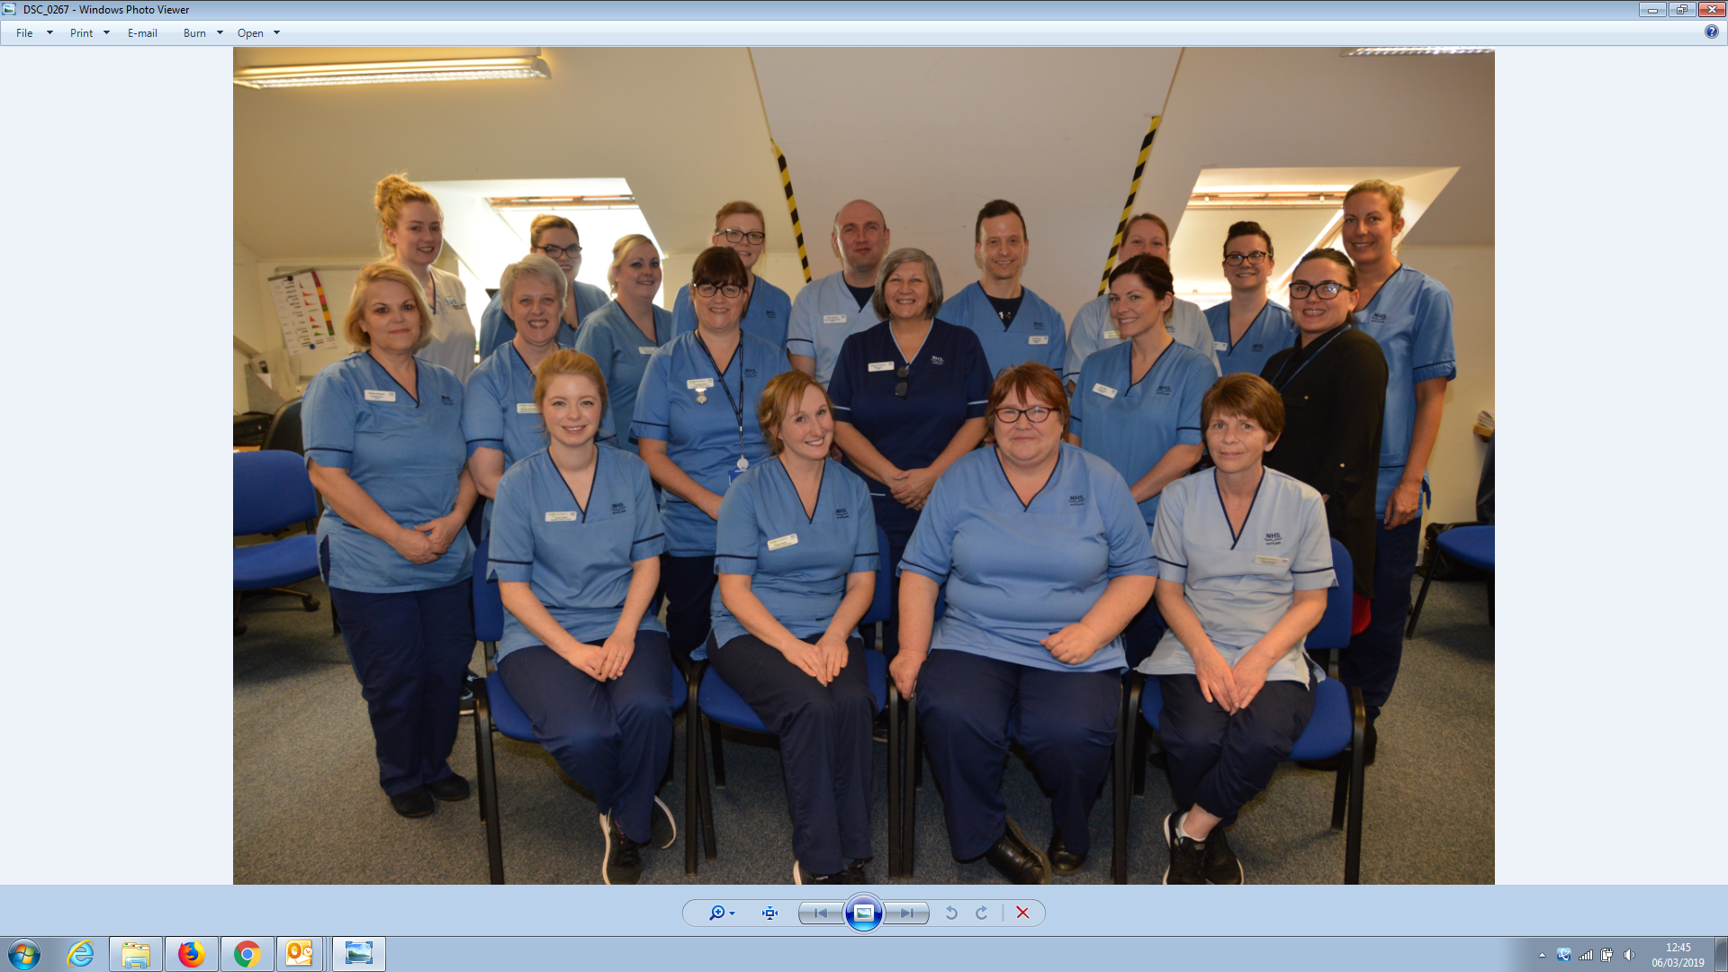

**What did we do**

The team were asked to participate in iMatter as part of the North H&SCP, initially we were all a little sceptical about what it would bring to us – would it be just another questionnaire / what difference would it make?

We are a community nursing service but based in a busy Acute hospital site so on receiving our results our manager arranged to hold a meeting off site so we could have time to dedicate to the process without any disruptions.

We held our team meeting in the training centre in May and looked at our report which showed we achieved an 89% response rate and an engagement score of 84. It was a good informal meeting with lots of tea, cakes, fruit and laughter along the way as we discussed the report and agreed

3 actions to take forward together.

**What was our action**

We want to share one of those actions with you. At our whole team meeting the team identified a gap in our knowledge in relation to our management team – who were they and what did they know about us as a team?

**We used iMatter as an opportunity to ask to meet up with our management team**.

We asked our Team Leader to approach the Senior Management Team, and invite them to an ICCNS team meeting where we could all meet face to face, ask each other questions and tell the SMT some of our triumphs and challenges.

Four of the SMT came along – Service Manager, Associate Director of Nursing, Associate Medical Director and the General Manager. Our manager introduced everyone then handed over to us as a team. Three of the team facilitated the meeting starting with a short presentation showing who we were / what we did as a service followed by a Q&A session.

Our Associate Medical Director said on the day “never has so much been done for so many children by so few nurses!” which was lovely for the team to hear.

The meeting was really beneficial giving us all a better understanding of each other’s work and helped explain how some of the things we are asked to do are vitally important to them as a SMT. One example was a workforce tool that we are required to complete three times a year which is very onerous and time consuming however once the Senior Team explained how invaluable this information is to them we could see the benefits.

***As a team we felt we were in control and that we were listened to.*** The Senior Managers also enjoyed the meeting and mentioned that when they were initially invited to come along they thought something was wrong and were really pleased to know that it was as a result of iMatter that we wanted to get to know them better.

Our Senior Management Team regularly do “back to the floor” and as a result of our iMatter action the team feel more comfortable and open during these informal walk rounds.

Despite being a little wary and cynical about iMatter we feel it has been really useful and helped us to recognise and celebrate how well we work together and the value we bring as a team.

*“I was aware of the work of the team, but it was good to hear it from the practitioners and see how motivated they are” SMT*

*“It wasn’t them and us” STAFF*

*“The management team knew exactly who we were and what our challenges were, which I had not expected”* STAFF

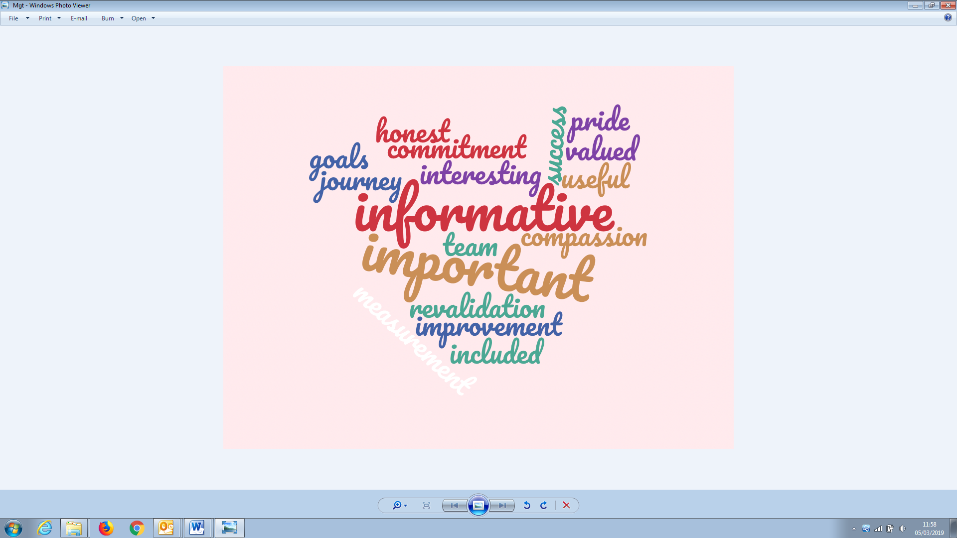

*“I felt please and encouraged at the meeting”*

*STAFF*

*“It was nice to hear the management team’s side of things” STAFF*

*“One of the highest performing teams in the organisation” SMT*

*“Open and honest atmosphere in the meeting” STAFF*

*“It was the best afternoon I’ve spent at work in ages” SMT*