Ward B3 – Dumfries & Galloway Royal Infirmary

Sustaining our High Standards is the name of the game!

In 2018 we achieved 43% response rate, for me as Senior Charge nurse for the ward I wanted to reach 60% and achieve a team report to help me know what staff felt it was like to work in our team.

Our ODL team supported us to find out why the team hadn’t completed the questionnaire last year. The feedback showed that staff didn’t feel they knew anything or enough about iMatter to participate.

The ODL team came to our ward and had mini awareness conversations with the team about why it was important for staff to share what they think and what iMatter was.

During the questionnaires we encouraged staff to complete their questionnaire and used our team whatsapp to ensure everyone across all shifts knew to look out for the link.

We achieved 64%! We were delighted to get a team report – and be one of the first wards in the Board too!

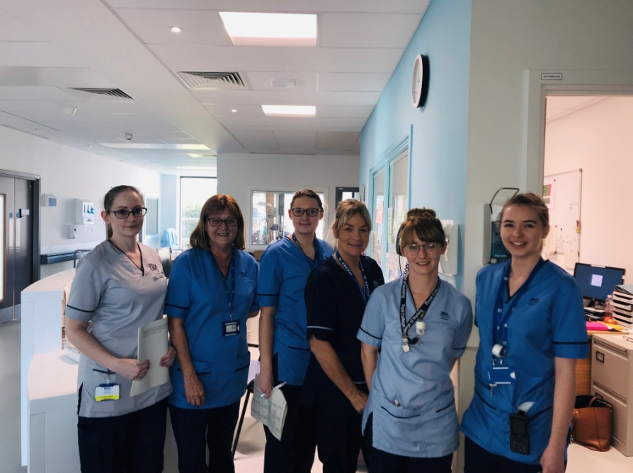

**Action planning**

Being on a busy ward we had to think outside the box to try and get everyone involved in the action planning

We put up a flipchart in the ward asking the team to share what they thought was good about working in B3 and what could be even better?

We then wrote up actions from the feedback and asked staff to feedback whether they agreed with these – everyone agreed to commit to these actions!

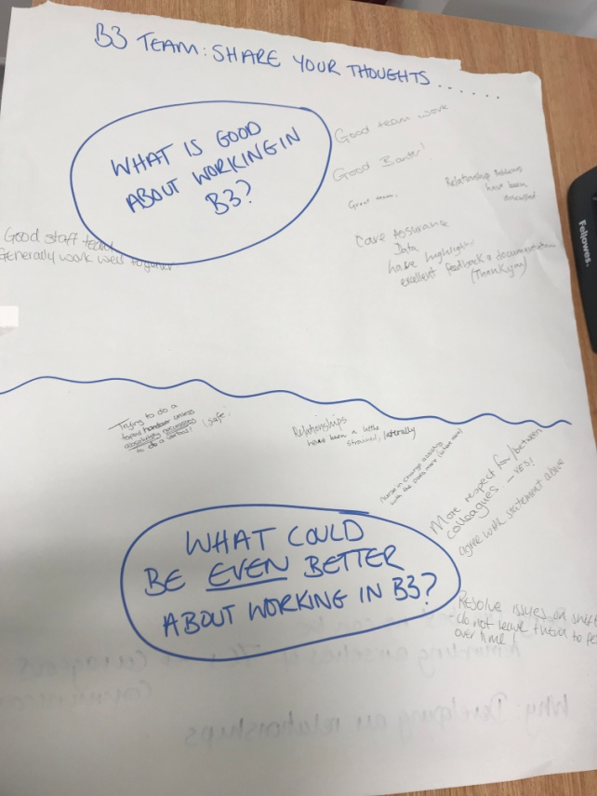

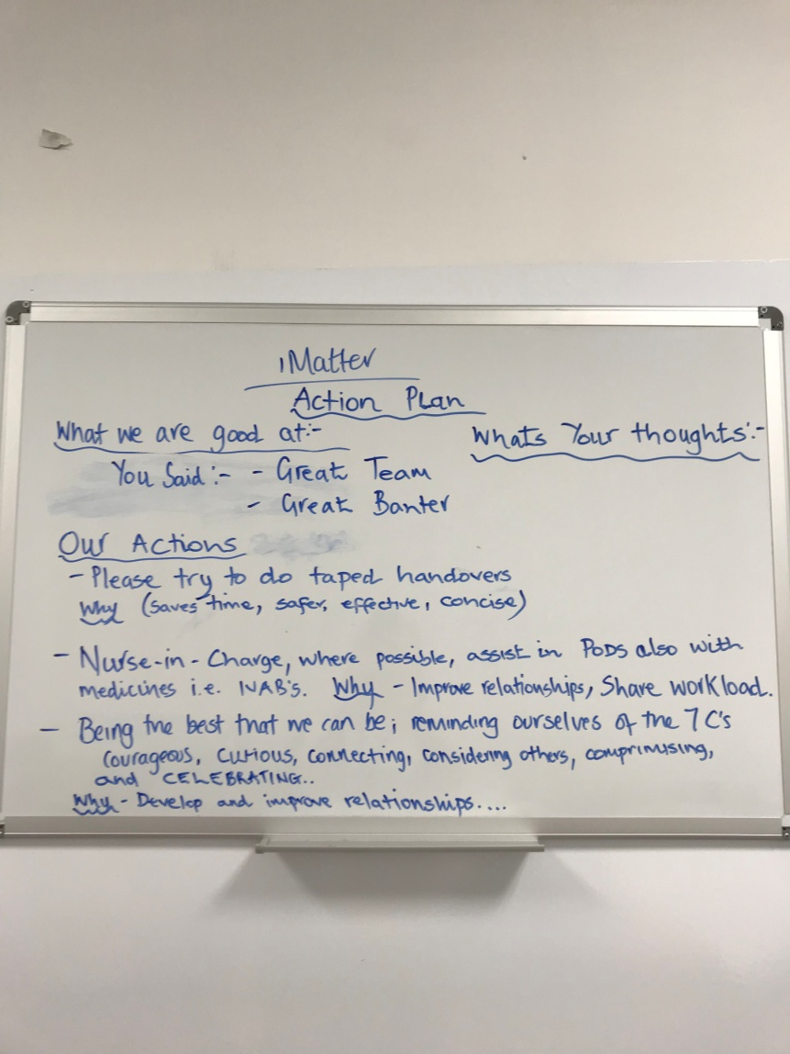

We think we have good team work, but hope that our action plan will help us continually develop.

And benefit our working relationships and motivation which will impact on our patient care and experience.