Text for Success!
Homecare – West Dunbartonshire HSCP
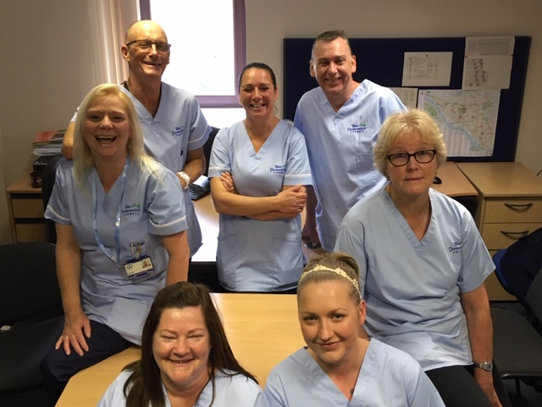
I’ve seen plenty of changes during my 18 years working in Care at Home Services in West Dunbartonshire. When implementing change, it has always been important to us to make sure that we hear the views of as many of my colleagues as possible, but it has often proved challenging to engage staff in the self-evaluation process. Like most HSCPs we have invested in using the latest technology in our service provision and yet, when it comes to staff surveys, we have still asked staff to complete paper questionnaires
Last year we were invited to take part in an iMatter questionnaire, and I felt sure that this would prove to be an excellent tool for improvement, allowing us to see clearly how staff felt about the service that we provide. Paper copies of the questionnaire were issued to all staff, but once again our home carers failed to engage in significant numbers.
That is when we decided to look into using mobile technology as a means to:
- communicate about the iMatter questionnaire with carers using text messaging; and
- allow carers to complete the iMatter questionnaire directly on their mobile telephones.
We approached Diana Hudson from Greater Glasgow and Clyde & Liz Reilly from the Scottish Government to explore how mobile phones could be used for this purpose. Working with Diana, Liz, and Webropol, they advised us that, employing the same technology we were already using, we would be able to create a template text message with staff’s personal details already completed and containing a unique URL (similar to a mail merge in word).
Webropol provided the necessary staff details in Excel format and the URL link for their questionnaire. We then simply completed a look-up from our HR system to select each carer’s mobile number and this created a personalised text message which was sent to each individual carer.
A pilot took place in March this year involving 40 home carers. An initial text message was sent to carers’ mobile phones explaining the purpose of the questionnaire, followed by two further text messages, one to provide the questionnaire link, and a follow up reminder message two days before the closing date.
The process was straightforward and not time consuming, and resulted in an unprecedented 80% response rate. The carers that we spoke to advised us that the questionnaire was quick and easy to complete.
Following the success of the pilot, we decided that we would immediately introduce the use of SMS to engage with our workforce. Home carers overwhelmingly embraced the use of SMS to complete the questionnaire, and over 85% of our carers responded.
As part of the process team reports were generated, allowing staff to discuss and celebrate the things that we do well, giving the whole team a real sense of achievement and allowing everyone to feel ownership of the improvement priorities identified from the responses to the questionnaire.
As a result of the feedback obtained from the questionnaire, improvements will be taken forward in the areas of communication, staff training, and the involvement of staff in decision making. We have started to develop new ways of working to ensure that staff have more access to their line managers and we are about to establish a communications working group. We are working jointly with our home carers and the employee development team to look at additional training opportunities and new ways of providing training using e-learn technology.
We shared our iMatter journey and the results with the Care Inspectorate during our recent inspection. They were pleased to see how we had used new technology to effectively engage with our staff and develop actions for development.
Their findings during the inspection mirrored what came out of the iMatter results, which is even more evidence of the effectiveness of iMatter.
We are thrilled with the success of the project, and excited about the potential of using this SMS technology to engage staff in the improvement process even more widely in the future.
Richard Heard, Care at Home Service Manager

