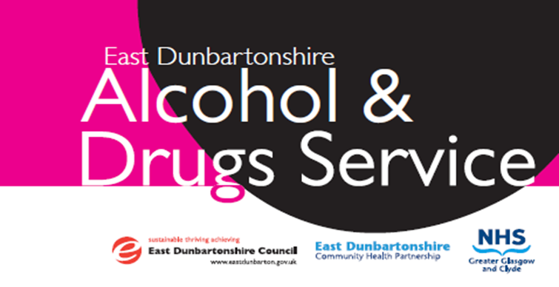

The Road to Success!

The Road to Success!
What We Do

We offer assessment, support and treatment for alcohol and drugs issues by offering person-centered, recovery-focused care and treatment. We are a family inclusive service. We may refer you to other recovery services with your agreement.

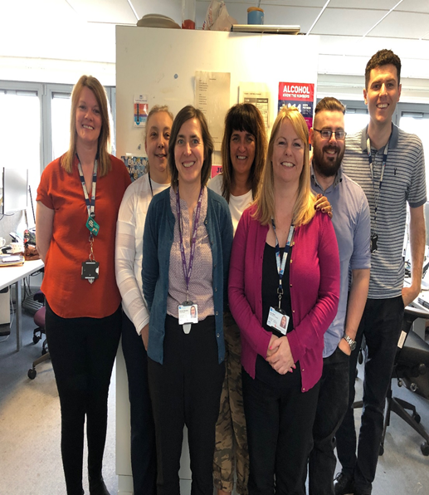
We are based in Kirkintilloch Health centre with satellite clinics in Milngavie and Lennoxtown (by appointment only). Home visits are available if required.
“Working together to support people to achieve their full recovery potential and reduce risks’

The Road to Success!

 | 2017 |  | 2018 |  | 2019
Response Rate | 71% |  | 71% |  | 80%
EEI score | 61 |  | 67 |  | 74
Component results | 7 Amber |  | 10 Yellow |  | 1 Yellow
 | 11 Yellow
 | 10 Green |  | 18 Green |  | 27 Green

We reviewed information on iMatter from over the last 3 years and we could see, from the team reports, how we have moved forward together. In 2017, our team component report showed a number of the questions scoring low (ambers and yellow), to mostly green with just one yellow rating in 2019.
iMatter provided us, as a team, the opportunities to focus on actions back in 2017, and, from there, continue to build on them over 3 years. This has not only made us a better team, working well together, but also improved the service we provide, which we see from the feedback offered, directly from service users. We’ve used the iMatter process as a means of continuous improvement, which we believe is what iMatter set out to do.
iMatter enabled us to facilitate discussions in team meetings around our successes, and areas for improvement which has helped focus our discussions and prompted us to review our progress year on year. We identified alternative, more effective & efficient ways of working to reduce staff pressures, alongside achieving better outcomes for service users and releasing time to care.
One key action over the past year has been to introduce a group supervision model with Addiction workers to promote and develop good practice and alternative methods of working. This method has supported and encouraged staff, but also to support a better experience for those using the service. This group has evolved using a motivational interviewing coaching model.
A further example of our success is that in the past we didn’t feel ready to submit nominations for the Staff Awards. This year we submitted 4 nominations showing our examples of good practice and of their clinical success – and we look forward to continuing to celebrate and promote our successes in the future.

STAFF QUOTES
‘Our integrated working practice allows for a smoother delivery of patient care’.
(Staff member)
‘The skill mix between disciplines provides optimum support to service users’.
(Staff member)

‘Working together with partner agencies allows us to see the benefits of assertive outreach’.
(Staff member)
‘Encouraged by the commitment of the team ensuring our service is family. Inclusive’
(Staff member)

SERVICE USERS QUOTES

'The Milngavie Clinic helped me get my life back together; they sent me on a path to a Fellowship and now I'm nearly 16 months sober'
Male (22)

‘Before engaging with EDADS I was stuck in a rut, feeling there was no way out. With determination and the great help of the team I’m getting back on my feet again’
Male (45)

‘Genuine concern and understanding leading to practical support and advice. This service works’
Male (47)

‘I engaged with EDADS and they helped me through my recovery journey a lot. They also helped me make my next step into employment and education. Can’t thank them enough for their service and all the help they have given me’
Male (30)

