iMatter Team Story

Board: The State Hospital Board for Scotland
Team Name: Learning & Development Team
Director Name: HR Directorate
Story Name: On a Mission!
Team Photo:

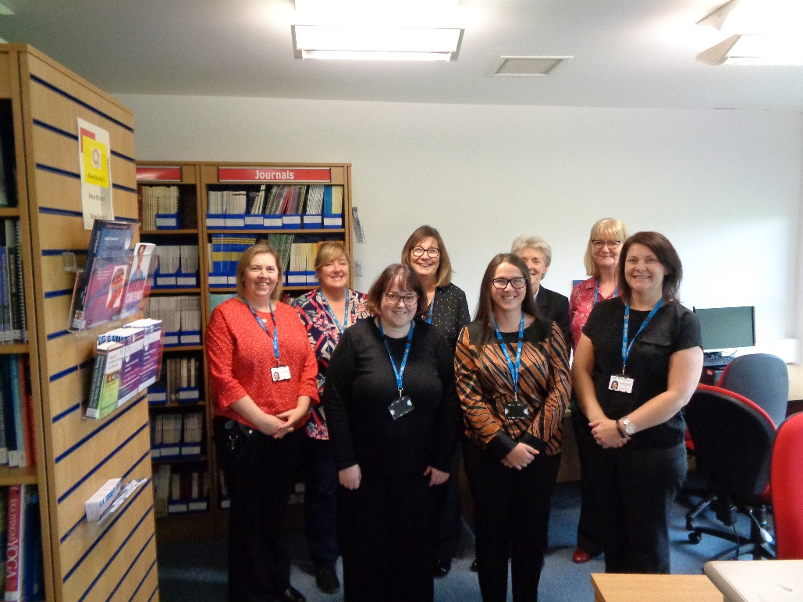

The Learning & Development Team – Who are we?

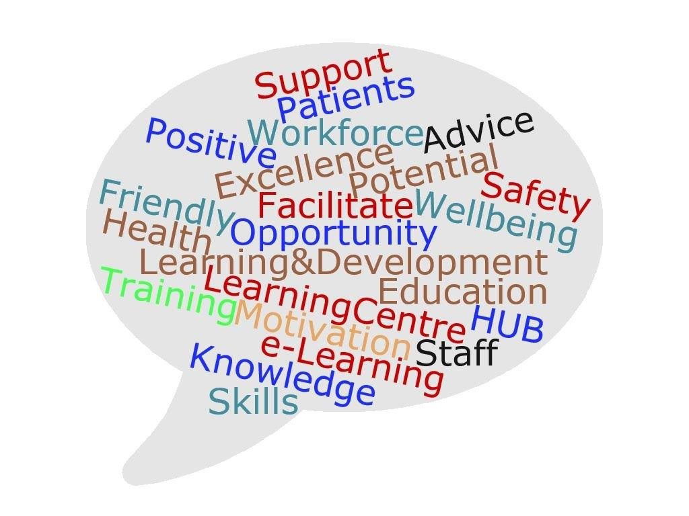 Sandra Dunlop
Training & Professional Development Manager (Team Manager)
Nicole Cavanagh
OD & Learning Secretary
Lynn Clarke
PMVA Advisor
Lynne Cockburn
Training Administrator
Sharon Corrigan
Learning Centre Manager
Rebecca Hart
Librarian
Lynn McCallum
Manual Handling Advisor
Julie McDonald
Patient Learning Manager
Gayle Scott
OD & Learning Advisor

Celebrating what we do well

We are a positive and motivated team with a broad range of knowledge and experience and a ‘can-do’ attitude that helps to ensure we are responsive to service user needs.

Our iMatter Journey

We decided and agreed the following areas for improvement:
- Clarifying and agreeing our core purpose and team objectives
- Maintaining regular feedback and line management support
What did we do?
- Engaged in a number of team development sessions
- Agreed a team mission statement and team objectives
- Developed an action plan to support achievement of the team objectives
- Introduced a schedule of regular 1-1 ‘workload review’ meetings
How did we do it?
The team asked ourselves the following questions:
- Who are we?
- What do we do?
- Why do we do it?
- What things add most value?
- What could we do differently or better?
We also used a range of team development tools to assist in developing our mission statement and agreeing our team objectives – for example, SWOT analysis, brainstorming, action planning and responsibility charting.
Our Mission Statement

Team Objectives

Key priorities that the team have identified for the coming year relate to:
- Marketing and promotion of internal and external learning opportunities.
- Maintenance of accredited centre status with qualification awarding bodies (e.g. SQA, BCS, ILM).
- Working collaboratively with other NHS Boards on L&D projects and initiatives.
- Ensuring efficient and effective L&D provision that meets organisational needs and legislative requirements.
- Improving corporate induction process.
- Improving the quality of the annual KSF personal development review process.
- Provision of leadership and management development programmes and resources to support people management and succession planning.
- Development of learning resources and programmes to support the staff health and wellbeing agenda.
- Enhancing opportunities to support/encourage young people into employment in the NHS (including extending MA opportunities).
What impact has it had?
- We improved our EEI score

- We improved scores across all of the iMatter questions and components!
- Members of our L&D Team have been nominated for a number of Staff Excellence Awards. This includes:
- Outstanding Individual (non-clinical) – Lynne Cockburn
- Outstanding Individual (non-clinical) – Rebecca Hart
- Outstanding Individual (clinical) – Lynn Clarke
- Outstanding Team (non-clinical) – Learning Centre Team

What next?
- Implementation, monitoring and review of our team objectives.
- Using Myers Briggs Type Indicator (MBTI) to leverage team strengths and support further improvements in team relationships and communication.

