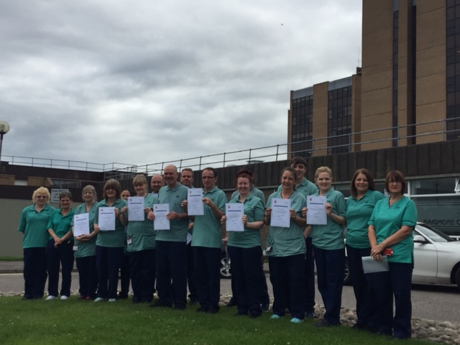

(Photo 1: Domestic Services Team, Raigmore, Cleaning and Disinfection Certificates)

Our Service Matters
Who are we…
We are a forward thinking highly motivated team of (181) professional health care cleaners, supervisors and manager based in Raigmore Hospital.
Our role is to provide a clean and safe hospital environment within the ninety thousand square metre hospital footprint. A key activity is to keep the hospital in a constant state of readiness so we can safely receive both emergency and elective patients. One of our most challenging tasks is staying motivated to clean 750 toilet outlets 3 times daily but we understand this work is vital in ensuring we contribute to breaking the chain of infection and reducing the spread of bugs like Clostridium Difficile. While we have always been proactive in developing and constructing working relationships within the team and outside the team we have always been aware that there is always room for improvement. What we were not sure about was how to do this.
Our iMatter journey…
We started our iMatter journey in 2015 and at first concentrated on getting staff engaged and promoting participation. We soon realised that the action planning stage could be used to address some of the key issues identified in our team reports.
Unpicking issues was not always easy and involved a lot of coffee and cakes, we worked initially on improving communication skills for our supervisors. We have accessed training to enhance our listening skills, and developed the skills to deal with difficult conversations. Through working together we have now developed a workplace culture that fosters team work allowing us to set clear goals and agree objectives with our individual teams and wider service users.
As we continued to participate in the iMatter process we began to recognise the potential to make significant improvements that would benefit us and the organisation. In 2017 and 2018 we identified in our action plans the requirement to raise our profile within the organisation and worked to position ourselves at the forefront of infection control. Some of our colleagues improved their skills and completed a Cleaning and Disinfection course through the Royal Environmental Health Institute of Scotland (photo 1). Our supervisors became more visible through attending and actively participating in daily huddles on the wards and some key committee meetings.
As we moved into 2019 we started to identify links between happy staff in a happy work environment where morale is a key factor in the work place. We began to think about mental health and wellbeing within the workplace, understanding how to deal with it positively and how to support each other. We engaged with Union Learning Reps who provided outstanding training days in this and other work place issues.
Our next exploration is into emotional intelligence and how understanding this subject will help us to develop even further. We have developed a poster which captures some of the key steps in our journey.

