iMatter: NHS Borders Work and Wellbeing
NHS Borders Work & Wellbeing Department consists of multidisciplinary teams, responsible for promoting staff health and wellbeing. As you can see in photo below some are camera shy! But not Honey Bee!
Honey joins the team once a year to promote the staff flu vaccination programme – maybe she should complete the iMatter questionnaire ????
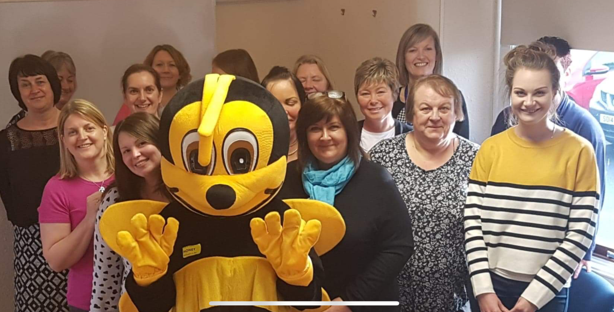
Staff have been completing questionnaires on an annual basis from the onset of iMatter.
What will results show?

Challenges?

Solutions?

What do we do well?

Like any team there is always challenges however overall we feel we work well in our individual teams and are able to offer support across the larger multi-disciplinary team.
Communication

iMatter results consistently show good engagement however, communication could always be improved and our action plans aim to develop this.
Our larger team has established dedicated time for daily staff communication updates. This ensures effective distribution of information that is clear, timely, concise and transparent.
Support

Office relocations have taken place resulting in a more inclusive working environment. This ensures access to support from colleagues is readily available.
Team building

We have evaluated meetings and introduced regular, short 1:1s as opposed to longer, more formal meetings. We are also making a conscious effort to spend lunch together allowing time for social interaction with colleagues and building relationships. We are now a more closer knit team which has led to a happier working environment. Looking after each other means we are better equipped to look after and support NHS Borders Staff.

iMatter has been very beneficial to our team giving us the opportunity to reflect on how we interact as a team and celebrating what we do well while striving for continued improvement

