**South Ayrshire Dietetic Team**

**Appreciative Inquiry/ iMatter Team Discussion and Resulting Service Improvement Projects in UHA**

AHPs were undertaking the Blue Wave of Change Improvement Programme (delivered by Fiona MacNeill Associates) when team reports from the staff iMatter survey were received.

We had been asked to implement our learning by undertaking an appreciative inquiry, linked to one of the AHP strategic intentions. Having considered the iMatter suggested process for facilitating team discussion also we felt these could be merged to allow us to have a deeper understanding of current thoughts and feelings that the team held with regard to uni-professional and wider organisational team working.

The outcome would then be that we would have a shared and agreed action plan to take forward.

The AHP strategic intention we linked this to was;

**‘AHPs will work at the top of their professional licence, and empower support workers, volunteers and other colleagues to make a positive difference’**

Having prepared the environment and welcomed our team we agreed our ground-rules and split into line managed teams to answer the following questions

* ‘Tell us briefly about a time when you had a good team working experience?’. (This could be any team working situation they had experienced and each person expanded on what had made this a particularly positive experience).
* ‘if you are working at the top of your professional licence, what would good team working look and feel like?’

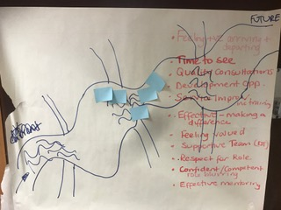

The iMatter process first asks us to identify what we do well and by working through the above questions, the UHA team agreed on the following statement;

**‘We are a friendly approachable team who are supportive of each other and have a good work ethos’**

On reviewing our iMatter team report it revealed that the areas that required improvement, on the whole, sat within section 4 ‘My Organisation’. Having discussed and identified what required to be improved, staff highlighted two main areas that they would like to focus on;

1. Organisational appreciation of our professional skills and knowledge and not being seen as a financial burden.
2. Time to spend on service improvement/ training.

* The overall responses revealed that staff were frustrated, feeling under-valued professionally, didn’t feel that their professional skills/ unique contribution was understood. Much of the frustration came from the low priority perceived to be given to nutritional care at ward level e.g. care plans in place are not executed by ward staff
* MUST screening for malnutrition is not completed or is incorrect, Oral Nutritional Supplements (precribable products) are not issued to patients,
* Supplement Monitoring Charts are not completed and Food Intake Charts are not filled in.

This then impacts on the holistic care of all patients in regard to their physical and mental health; ability to repair, fight off infection etc. This can contribute to increased length of stay, clinical risk and reduced cost effectiveness of overall care.

There was agreement that these frustrations were likely to always be there unless we tried to do something different. We would need to invest time to try and influence this.

Our agreed iMatter Actions were;

* Invest time in service improvement and/or provision of training whilst building on relationships at ward level
* Improve communication with AHP Senior Manager/ AHP Associate Director to enhance their understanding and appreciation of the value of the Dietetic contribution.

As part of the Blue Wave training we were lucky to be in the position that our project was chosen to work through with help from other AHP colleagues.

This involved drawing a 2D model of our idea.

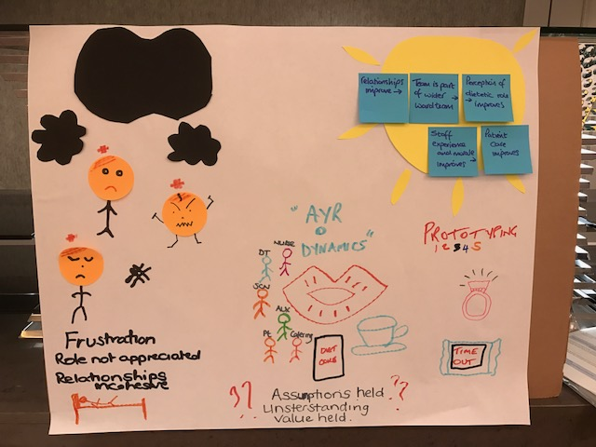

This was scrutinized by our AHP colleagues, each of whom then left us with two pieces of feedback. One thing they liked about the proposal and one question. This proved to be invaluable and allowed us to consider more deeply how we could achieve what we were setting out to do. Having done this we then produced a 3D model to depict our intentions.

|  |  |
| --- | --- |
| IMG_0619.JPG | IMG_0620.JPG |

The opportunity to spend this preparation time and to have input from other disciplines allowed a more focused discussion at our next team meeting when we decided how to take forward our plan.

Resulting changes were

* ward ‘focus groups’ was going to be very difficult to achieve. Instead we identified the Senior Charge Nurse to be our vital link.
* Staff were given permission to identify time- out to dedicate to spending the time they required.
* Acknowledged that, through following improvement science methodology, we would need to keep the target areas small if we were going to achieve any positive outcomes.
* The agreement therefore was that each Dietitian would select **one** ward only, where they assumed improvements were required, and to identify **one** improvement in that area to take forward.

Each Dietitian identified their own improvement plan for the individual ward they had identified. This became their service improvement objective which every AHP member of staff was expected to have, as directed by the AHP Associate Director. An SBAR report was completed by each member of staff and discussed with their line manager at their 3 monthly review.

Example SBAR

|  |  |  |
| --- | --- | --- |
| Situation |  | Hospital dietetic team iMatter action plan – ward improvement work  Area for improvement  To confirm our value and prove that dietetic input is effective we need to invest time on service improvement work and the provision of training whilst building relationships with the other staff groups. This will allow other health care professionals to have respect for our role and a better understanding of what we can deliver, which will be valued. |
| Background |  | It was noted that prescribed oral nutritional supplements were not routinely being given to patients on the ward with patients regularly stating that they were not receiving their supplement drinks and kitchen staff also commenting on the number of supplements being returned from the ward.  This was very subjective and anecdotal, time was required to audit current practice regarding the distribution of prescribed oral nutritional supplements to patients and the completion of the supplement monitoring charts. |
| Assessment |  | Supplement audit competed – 11th August 2017 (am & pm ONS)  (n=15)   |  |  | | --- | --- | | ***Outcome*** | ***Result*** | | **DTR updated by RD** | 100% | | **Sent as ordered from kitchen** | 100% | | **Delivered to patient** | 40% \* | | **Accepted by patient** | 100% (of supplements offered) | | **Monitoring chart updated** | 0% |   \*One patient reported that they had to request ONS from nursing staff (both their morning and afternoon supplements) this had not been offered without promoting. |
| Recommendations |  | * Pantry nutrition board to be updated timely for all patients requiring assistance at meal times (red tray system), or receiving a texture modified diet, as well as for any patients scoring one on the MUST and all patients on the dietetic case load. This is a shared multidisciplinary responsibility between nursing staff, dietitian and speech and language therapist. * Bed boards to be completed accurately with nutritional information to prompt staff with regards to therapeutic diets and oral nutritional supplements. * Dietitian to add food and supplement monitoring charts to end of bed clip board to prompt staff to complete. * Supplements to be given out at set times on ward – 11am and 2.30pm.   Audit and evaluation assessing the impact of the recommendations is ongoing on the ward. |

**Appendix 1**

The Dietitians presented their work to the AHP Senior Manager and AHP Associate Director. This session also allowed them to promote their professional role and discuss their unique contribution.

Many of the improvement projects are ongoing and some re-evaluation is required to ensure full implementation is maintained before the learning can be spread to other ward areas.

Improving relationships with other HCPs was also an important part of this process. It was therefore vital that we also identified improvements that we could make as a service to help with the ward processes.

We are also working with the clinical nurse managers to refresh and refocus nutritional care in the New Year

Staff have been learning from one another and some of the improvements identified in one area have been implemented by other Dietitians in their own ward area.

Both line managed teams also undertook strengths based training in conjunction with the OD team and are working together to make best use of this learning in future team-working

Maureen Murray and Jane Collier

November 2017