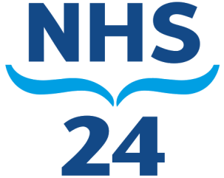
NHS 24 iMatter Story 2018

NHS 24 has rolled out iMatter across all Directorates and adopt a proactive approach to iMatter in terms of planning and resolving issues. Particularly within Information and Communications Technology (ICT), Ann-Marie Gallacher, Chief Information Officer and also NHS 24 Executive Sponsor iMatter adopts a continuous improvement approach to planning in terms of iMatter.
Recently there was an area within Information Governance which is part of ICT which needed an issue resolved involving listening to calls and data protection. Previously the Information Governance Officer had to make a request to our Service Support Team if he required to listen to any historical calls and this delayed the process and had to be done every time he needed to listen to calls.
The Chief Information Officer spoke to the Medical Director to get the Information Governance Officer special access so that he can access the system as and when required. This was duly done and it has made the process of listening to calls much easier and also improved the turnaround of each request.
This is an example of looking forward to see if there is anything that can be done to help streamline processes and improve the journey for our colleagues. This approach is being applied across NHS 24 as an organisation and will help NHS 24 colleagues feel engaged and achieve their goals faster and more effectively.

