**iMatter AHP Story 2018**

***“Our AHP Journey in The State Hospital”***

Background

Over the last 20 years, the AHP services at The State Hospital have evolved from Occupational Therapists (OT) to a wide range of professions including dietetics, physiotherapists, podiatry and arts therapies (drama, music and art). The last decade has seen changes moving away from uni-disciplinary working to all AHPs working closely together. With a new AHP lead in place in 2017, it has been an opportunity for therapists to develop their remits as individual disciplines felt that they lacked identity as an overall AHP group. It was fact we did not often meet as an AHP group, we lacked opportunities to network and share ideas and we were not working together regarding achieving our local and national policy drivers. The aim of our journey was to become more cohesive and visible as one Allied Health Professional Team within the State Hospital.

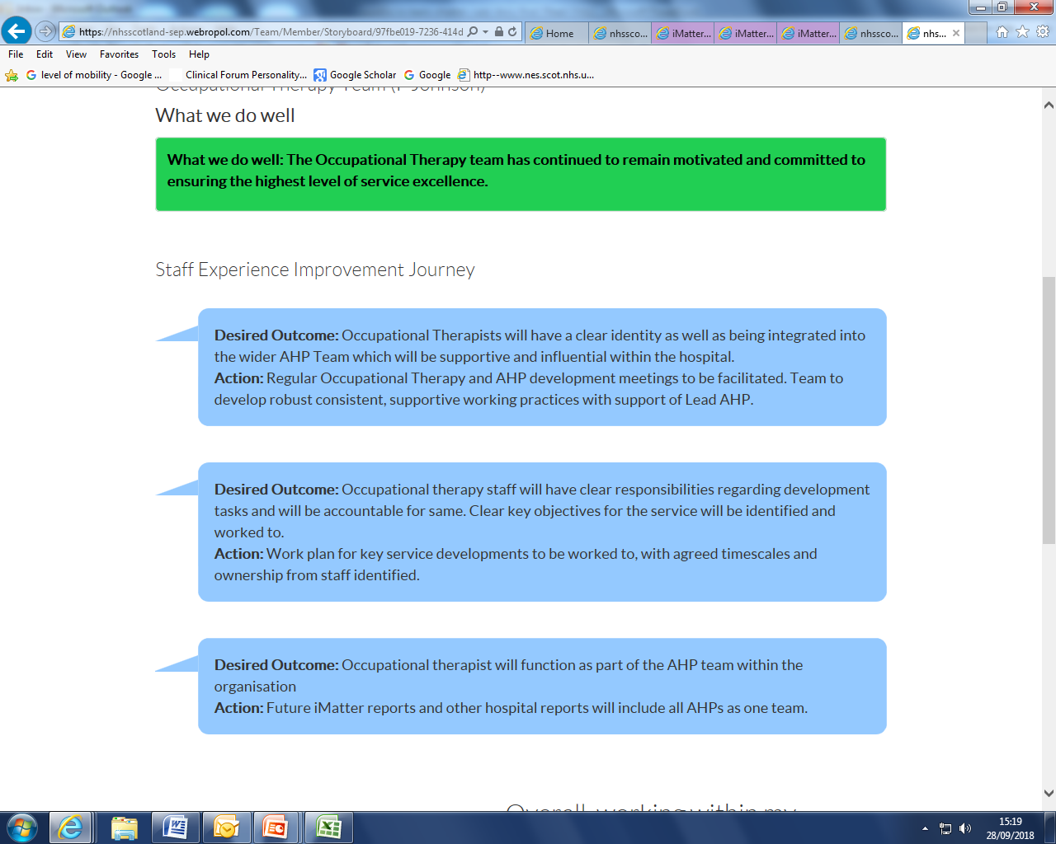

**OT Service example: 2017 iMatter Storyboard**

**What we did**

* Established monthly Continued Professional Development meetings as an AHP group
* Started a monthly AHP business meeting
* Established regular weekly time for AHPs to meet over lunch to improve contact and team relationships
* The Appreciative Inquiry model was used among the largest AHP group, Occupational Therapy, as a means to plan service development with discussions to expand to full AHP service.
* All AHPs are managed under one AHP Team Leader.

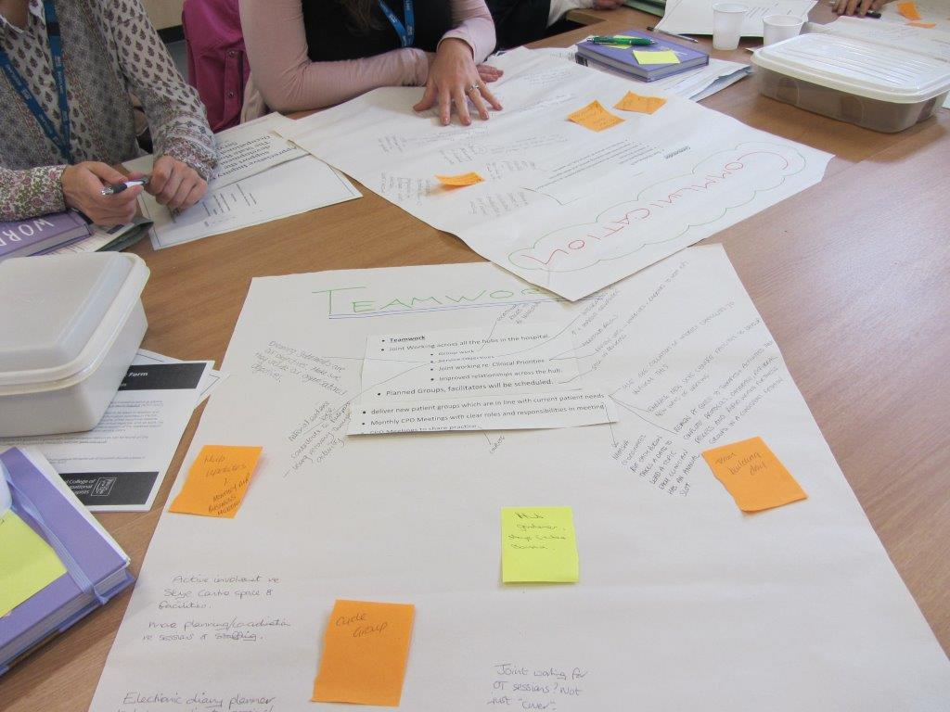

*OT utilizing the Appreciative Inquiry Service Development Model*

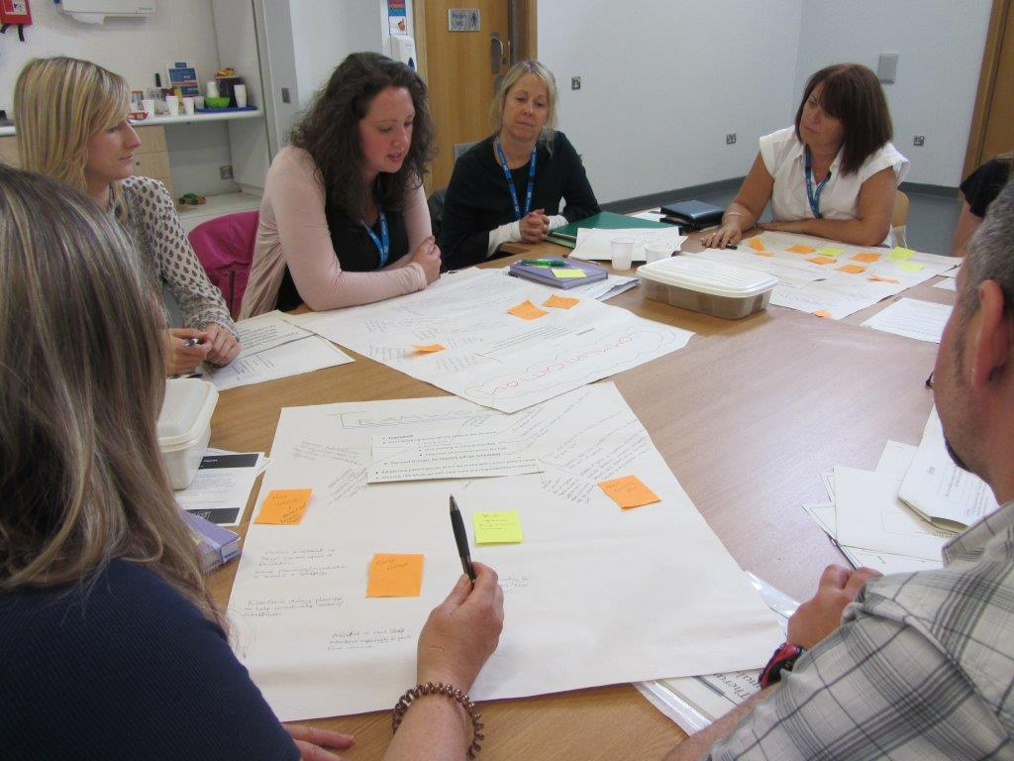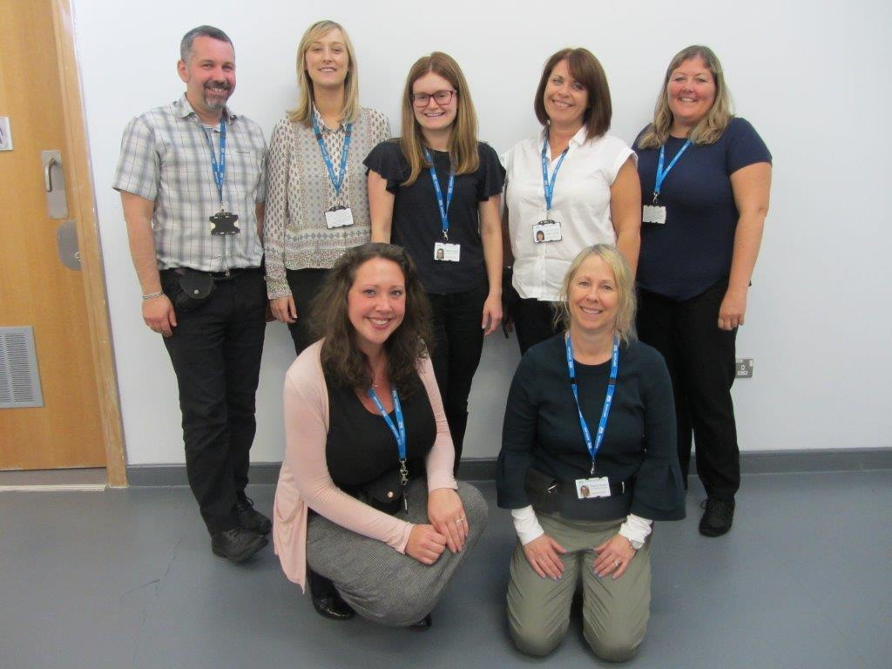

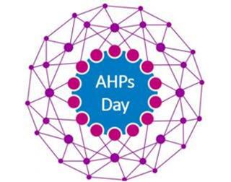

**Celebrating 1st National AHP Day at the State Hospital**

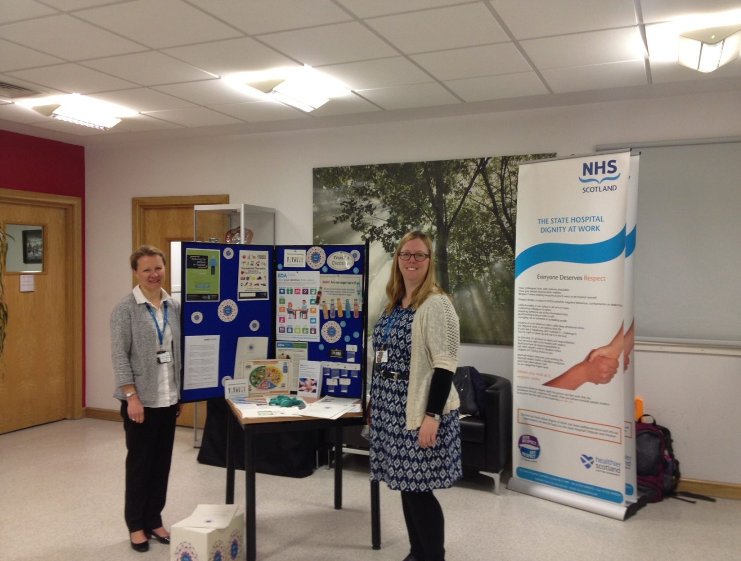

Greeting our colleagues at the main reception on national AHP day to raise our profile

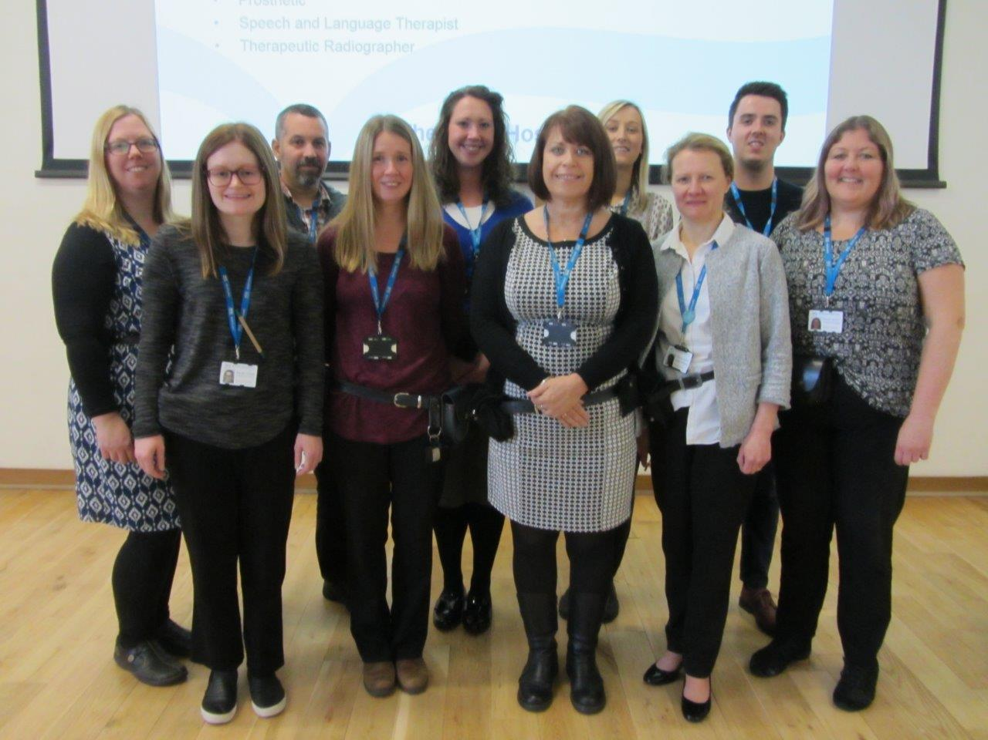

Delivering an AHP interactive journal club for the wider hospital to promote AHP roles

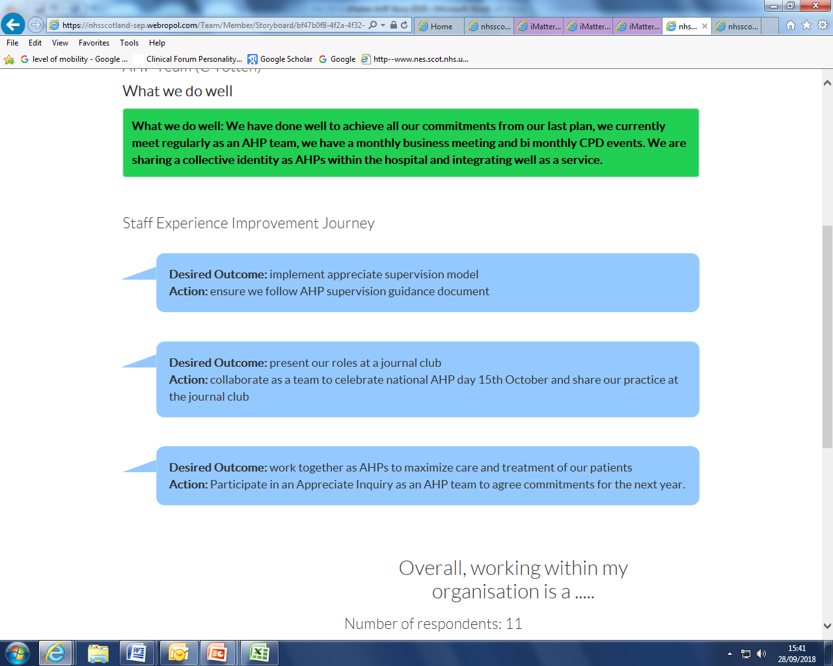**Where we are now: AHP iMatter 2018 Story Board**

**Desired Outcome:** Implement Appreciative Supervision Model

**Action**: Ensure we follow AHP supervision guidance document

**What’s the impact?**

More efficient and productive services;

**Desired Outcome:** Present our roles at a Journal Club

**Action**: Collaborate as a team to celebrate National AHP day 15th October to share our practice at the Journal Club

**Desired Outcome:** Work Together as AHPs to maximize care and treatment of our patients

**Action**: Participate in an Appreciative Inquiry as an AHP Team to agree commitments for the next year

**What’s the impact?**

More efficient and productive services;

* Improved joint working between all AHP groups for patient rehabilitation
* Cohesive approach to improved patient outcomes
* Co-facilitated sessions and joint group work
* Enhanced AHP identity within the State Hospital