Integrity to the Value and Purpose

Acute in-patient physiotherapy team - Dawn Gleeson, Acute physiotherapy Co-ordinator, FVRH
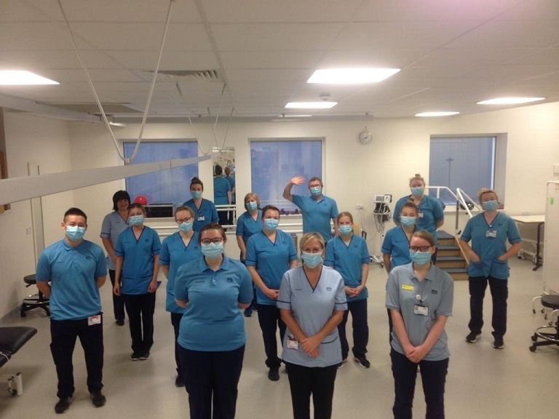

At the time that covid was expected we were, like all other staff, anxious regarding PPE and what was ahead of us. We gained additional physiotherapy staff from other teams whose work was suspended temporarily. The additional staff didn't really know the ward staff but they gelled together into one big team instantly and treated each other with utmost respect and care. They moved onto different work rotas as was required of us without any level of apprehension or reserve for their personal impact and they provided a high standard of physiotherapy service across all wards. Each morning we met to plan the day and they all looked back at me with large eyes but also contributing to the planning with their ideas and suggestions. They formed the most amazing large team almost overnight. I was never in any doubt of their anxiety but at no time did this present itself as anything negative. They supported each other, listened to each other’s concerns and worked together to share the work. They provided a high level of service across all wards which they always do but the thing that is wonderful was their approach to the whole situation as a team. I am sure this was the case in all teams but I can only comment on my team and I am so very proud of them. They are now exhausted of course, and we head into winter with an increasingly busy hospital and the anxieties are increasing a lot again. It’s not an individual story, but a team story.

