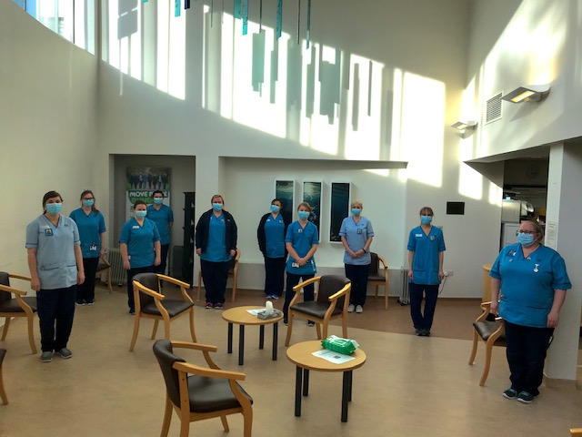
The Smile Behind The Mask

The Covid-19 global pandemic has brought about many challenges across all areas of the healthcare sector. Staff have had to change and adapt the way in which they work, at times on a daily basis. Patients themselves have had to adjust and become accustomed to these ever-changing adaptations put in place to protect them and staff alike.

In our small Radiotherapy department, we are proud of the rapport we build with all our patients during the course of their Radiotherapy treatment, which can sometimes be over a 6-week period. This everyday communication, be it words or a gentle reassuring smile helps build a strong emotional connection with our patients, not only helping them come to terms with their diagnosis but encouraging openness and trust between patient and professional. We value our patients’ thoughts and feedback and endeavour to take these onboard and implement any changes to improve their care within our department. Patients have often commented how they feel "well cared for" and "looked after" when attending their daily appointments. For us as healthcare professionals, this is the ultimate gratification.

The implementation of staff PPE due to Covid-19 was very much welcomed to help protect both staff and patients. Especially our patients; who can be some of the most immunocompromised and vulnerable within our communities. However, with the donning of face masks, the change in patient and staff dynamic was clear to see. Patients were unable to recognise staff members as most of our faces were hidden. That encouraging smile and look of recognition and reassurance was no longer visually apparent. Often when a patient was called through for treatment, they'd make a passing comment to staff as to who was treating them today, as they could not fully recognise the staff member behind the mask. As therapeutic radiographers, who take pride in the relationships we form with our patients, to find out patients felt disengaged was quite disheartening.

Zoe, a senior radiographer in the department and a well-respected colleague, came to me with an idea of photograph badges which she had seen implemented in other areas of the hospital. We came together to create a template with a photograph showing a smiling member of staff without their mask with their name below. The 'smile behind the mask' badge was such a simple yet effective concept to help patients identify with staff and bridge the gap, where patients were missing that facial expression and staff interaction.

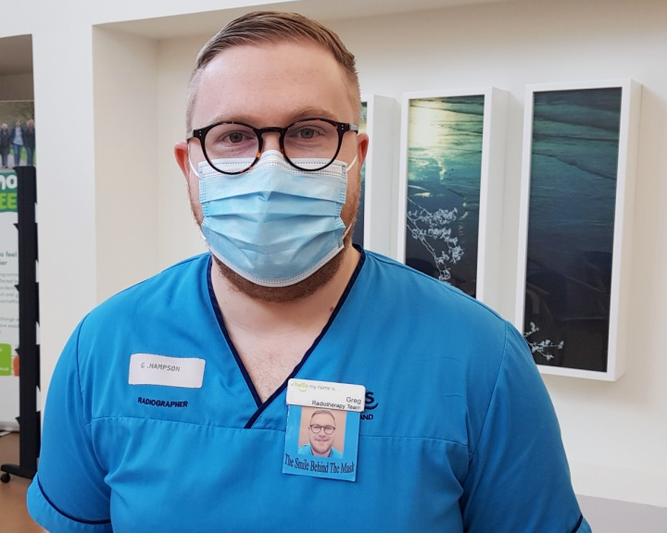
As healthcare workers, we endeavour to deliver the best standard of care to our patients and it is our responsibility that this is consistent no matter what challenges need to be overcome. This desire to help patients led to many staff requesting their own badge and ultimately led to a departmental roll out, including staff in other nearby clinical areas. The feedback from patients was very positive. Patients commented on what a great idea the badges were and how appreciative they were that we had spent time making them. No matter where you go, the badge always brings a smile and for that we are proud. Following the NHS Tayside Communications Team becoming aware of the badges there was a small publication which led to our template being sought after by different healthcare departments across Tayside.
It is good to acknowledge that even the smallest changes that seem insignificant on the whole, can have a positive impact on someone, especially in these unfamiliar and trying times.

