Solutions Focussed Approach in AHP Medical
North Sector (NHS Greater Glasgow & Clyde)
The team have undergone some restructuring over the last couple of years and this was the first time they completed the iMatter survey as a refreshed team. I led a team session focused on their results with a view to celebrate the things the team feel are going well and come up with meaningful actions relating to the areas that the team felt require improvement.
From our report, we could identify that the questions that stood out for us, and needed time for discussion were:
- I am given the time and resources to support my learning growth
- I get enough helpful feedback on how well I do my work
- I feel appreciated for the work I do
- I feel involved in decisions relating to my organisation
- I feel senior managers responsible for the wider organisation are sufficiently visible
The team session was very positive with a solutions focus. We looked at the areas identified above, and so the key outcomes for us to focus on as a team, included learning and development within the team, appreciation of what is going well and visibility and engagement with the wider organisation.
Through the iMatter discussion the team said they “felt listened to and appreciated the opportunity to make suggestions for change”, and it “gave the opportunity for everyone to give their ideas for solutions.”
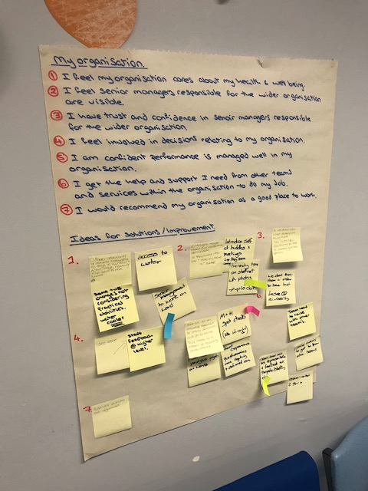
The team were able to reflect on their individual responsibility relating to personal development and ways they could be more proactive with identifying their needs and allocating time in their schedules to progress this. The team are keen to enhance appreciation of what they are achieving individually and as a team and developing mechanisms to do this.
They have suggested that senior managers could be more instantly visible to all staff if they embraced the “Hello my name is” badges and will seek to invite members of the senior management team to team meetings and consider what they wish to promote and share at these engagements.
The team acknowledged improvements in staff wellbeing with sessions available to staff e.g. yoga and mindfulness but had suggestions around how these could be advertised better and consideration given to staff being supported to attend these more readily.
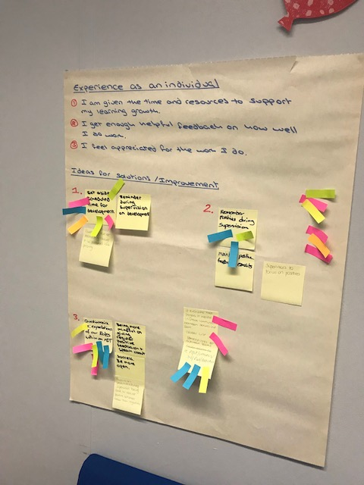
I was initially concerned that the session might get stuck in the negative issues but the team took the opportunity to discuss difficult areas, hear different views and then focused on solutions.
Team members found the session very positive and collectively they will monitor their actions, review progress and are aiming to improve their EEI score next year. I feel that the iMatter process overall provided me with the opportunity to hear the views of all members of the team and discuss and understand these in a very open and collaborative way. Line Manager – Lucy Devaney

